5



Document | Bring up report
Project | Flexi Teer
PCB | Rev2.0
PCB SN | #1...#5
Authors | MD Anderson,  Dennis Yaskevich
Date | ongoing
Version | ongoing

1. Orientation

1.1 What is the purpose of this document
This document describes the initial bring up (verification) testing of the FlexiTeer rev.2 hardware. All of test performed and the issues detected during the testing must be reflected in this document.

1.2 Who should read this document
This is deeply technical document more inclined to electronics design. It mainly useful for the engineer who is designing the second revision of hardware to see at glance all of the issues the previous revision had.

1.3 Requisite documents
Table below contains the relevant design documentation and it’s current versions as of writing of this document.
Document name | Link to the document | Latest updated on
Schematic_Flexi-TEER_2023-02-18.pdf | GitHub | 2023-02-18
PCB Layout | oshwlab.com | 2023-02-18

1.4 Test environments
Currently 2 people are working on the project.
Test environment | Test engineer | Equipment available | Test to be performed
Boston Children Hospital (BCH) | MD Anderson | To be completed | Shorts and resistance measurement
Hackerspace Krakow (HS) | Dennis Yaskevich | - USB Microscope NB-MIKR-300,  - Bench Multimeter Keysight EDU34450A  - Soldering station ZD981 | Visual inspection  Shorts and resistance measurement

1.5 DUT block diagram
Device Under Test (DUT) block diagram is provided below. Functionality of each block on the diagram must be verified during the BringUp testing.

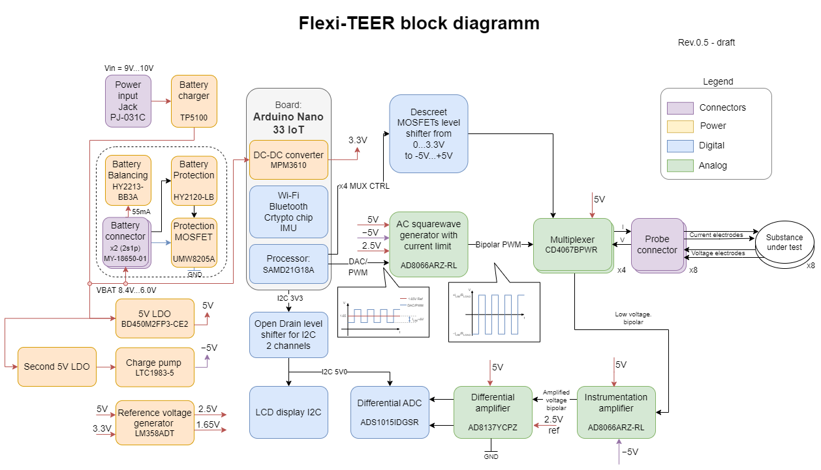

1.6 Test plan

Test site | Basic testing |  |  | Functional blocks verification
Test site | Visual inspection | Power rails resistance | Power rails voltage | Bi-level converter module | Multiplexer (MUX) | AC Generator | Battery charger | Battery balancing circuit | Battery mana-gement | Voltage processing instr. amp. | ADC Driver | LCD Display
HS | done | done | done | done | planned | partly | partly | - | - | planned | planned | done
BCH | done | done | done | done | done | done | - | - | - | done | done | -

2. Basic hardware testing

2.1 Visual inspection (HS)
Test equipment:
        - USB Microscope NB-MIKR-300

Designator | Footprint | Qty. | Manufacturer Part | Image | Status
U34,U35 | SOT-23-6 | 2 | HY2213-BB3A | 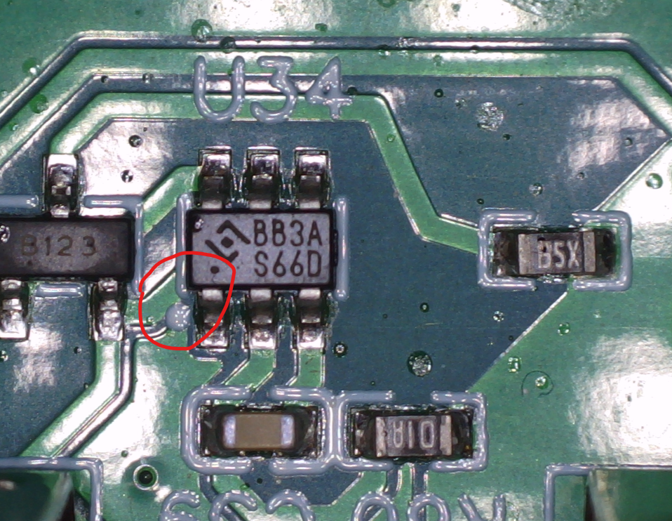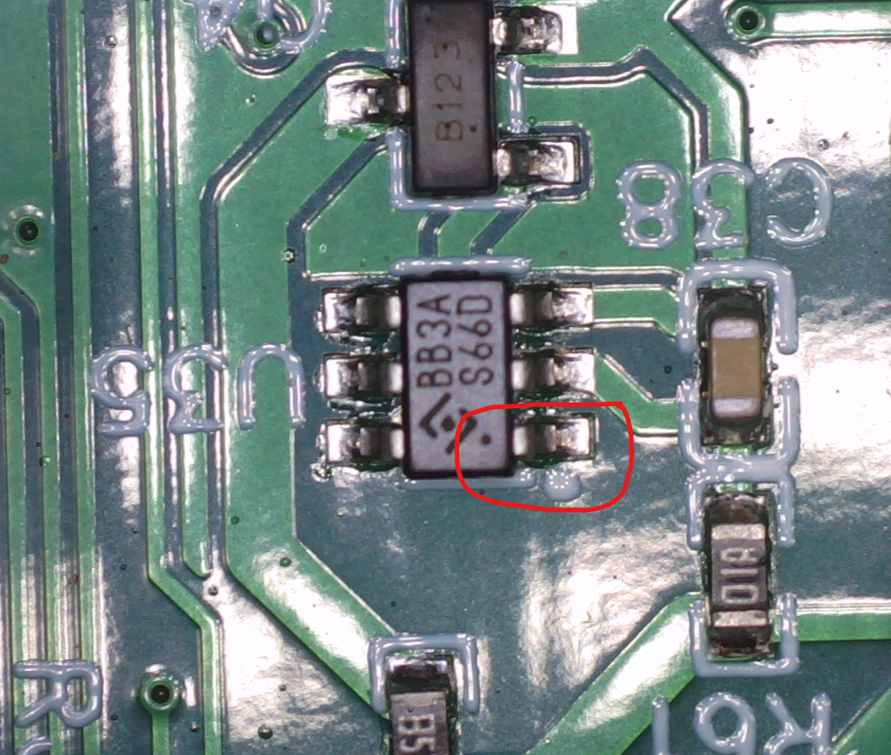 | OK
U33 | SOT-23-6 | 1 | HY2120-LB | 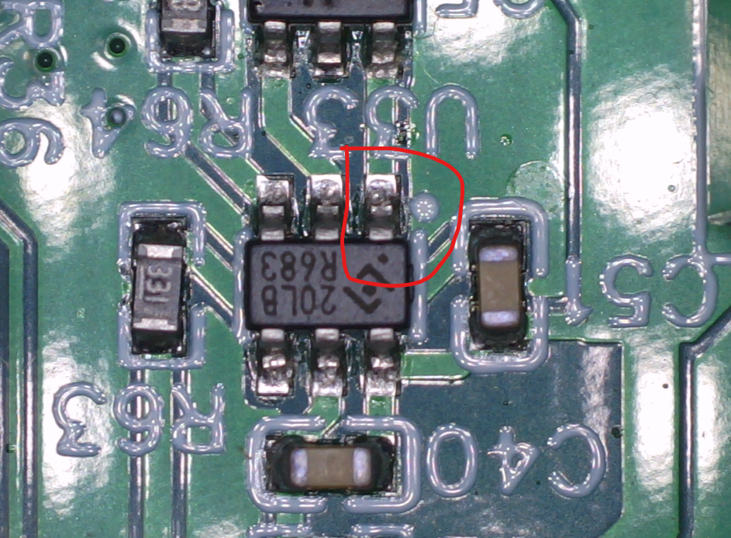 | OK
Q5 | SOT-23-6_L2.9-W1.6-P0.95-LS2.8-BL | 1 | UMW8205A | 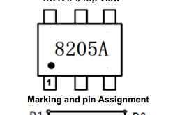  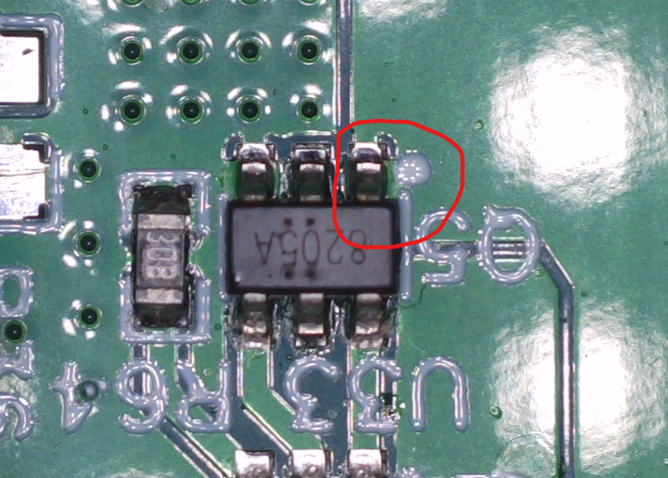 | Warning  (no 1 pin mark  weird burns on the IC)
U3 | WSON-8 | 1 | LM27761DSGR | 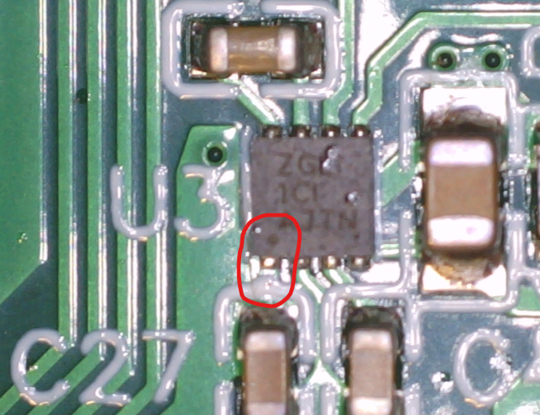 | Warning (1 pin indication is not visible on sickscren
U4 | LFCSP-8 | 1 | AD8137YCPZ-REEL7 | 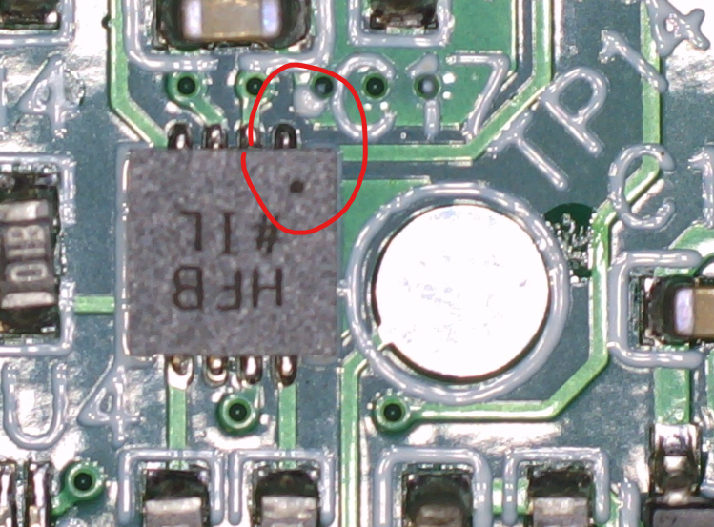 | OK
U5 | VSSOP-10 | 1 | ADS1015IDGSR | 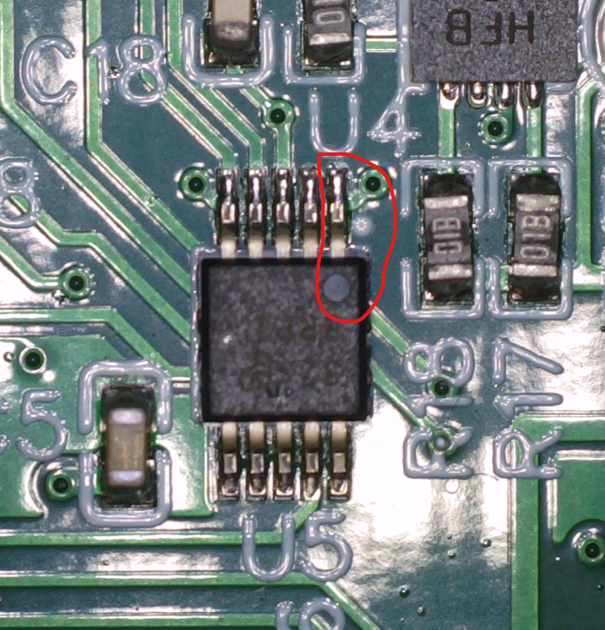 | OK
U26 | TQFN-16 | 1 | TP5100 | 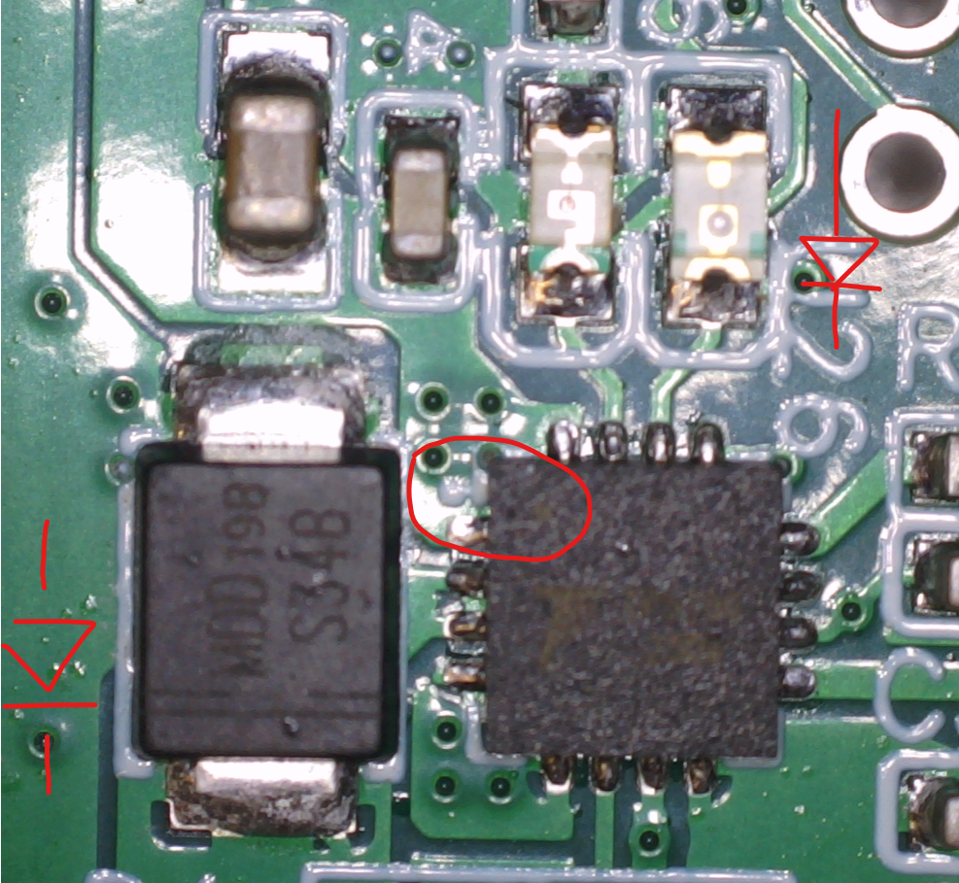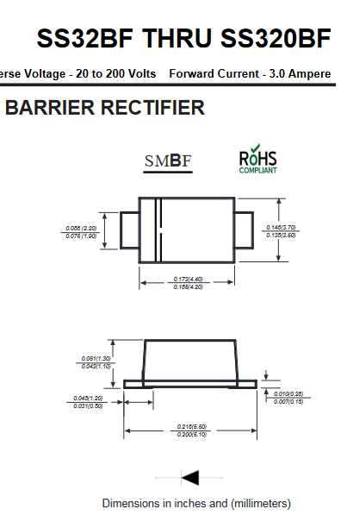 | OK
D4 | SMBF | 1 | SS34BF |  | OK
LED5 | LED0805-RD | 1 | 17-21SYGC/S530-E2/TR8 | 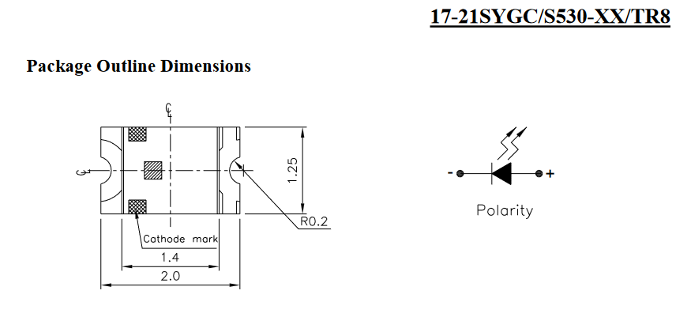 | OK
LED6 | LED0805-RD_ORANGE | 1 | XL-2012UOC | 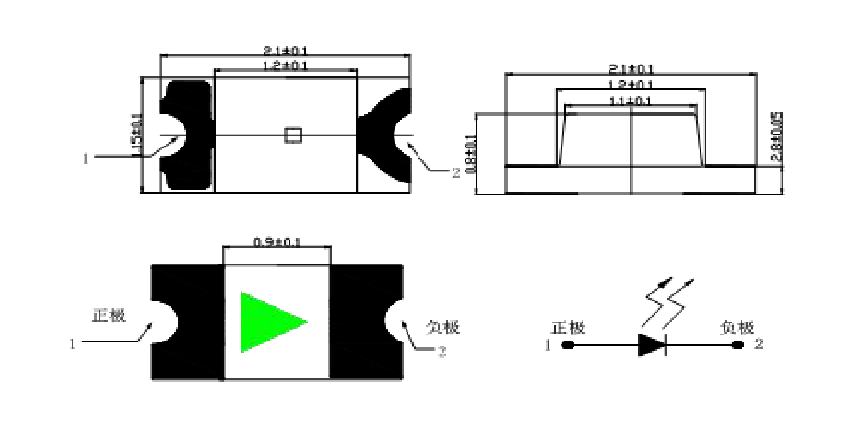 | OK
U11 | TSSOP-16 | 1 | TXB0106PWR | 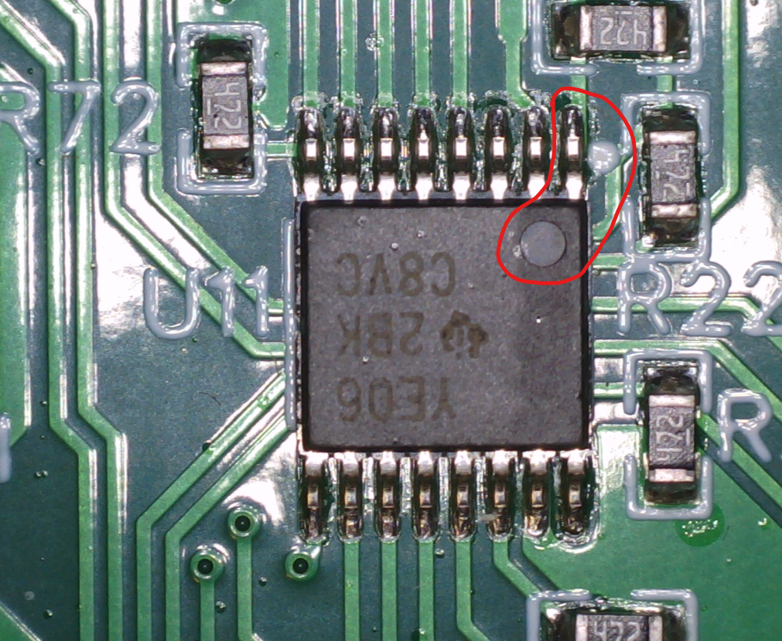 | OK
U1,U6, U7,U10 | SO-24 | 4 | HEF4067BT,653 | 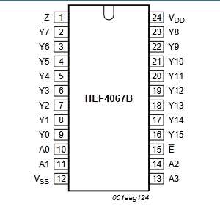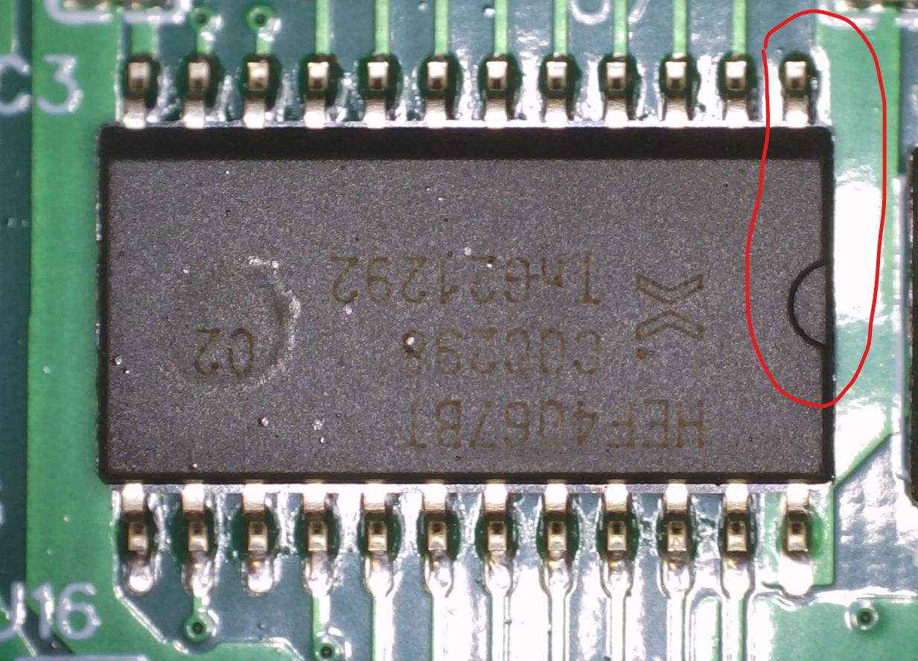 | Warning (1 pin indication is missing on silkscreen)
U2,U29 | SOIC-8 | 2 | AD8066ARZ-RL | 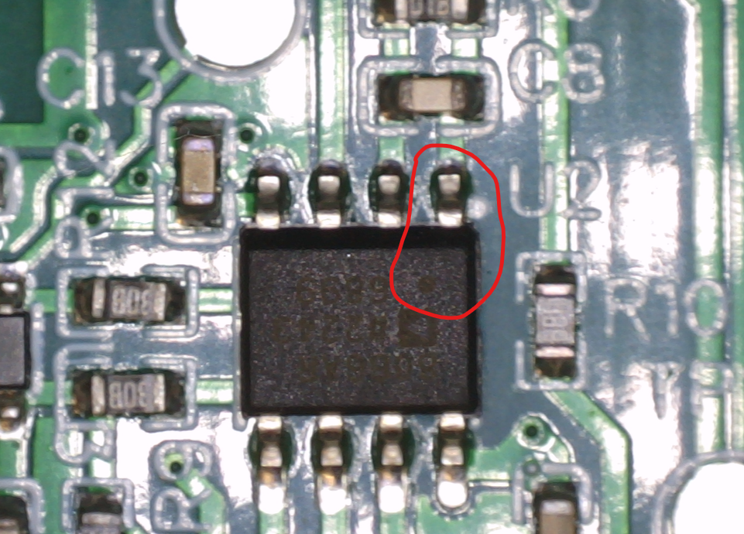 | OK
U30 | SOIC-8 | 1 | LM358ADT | 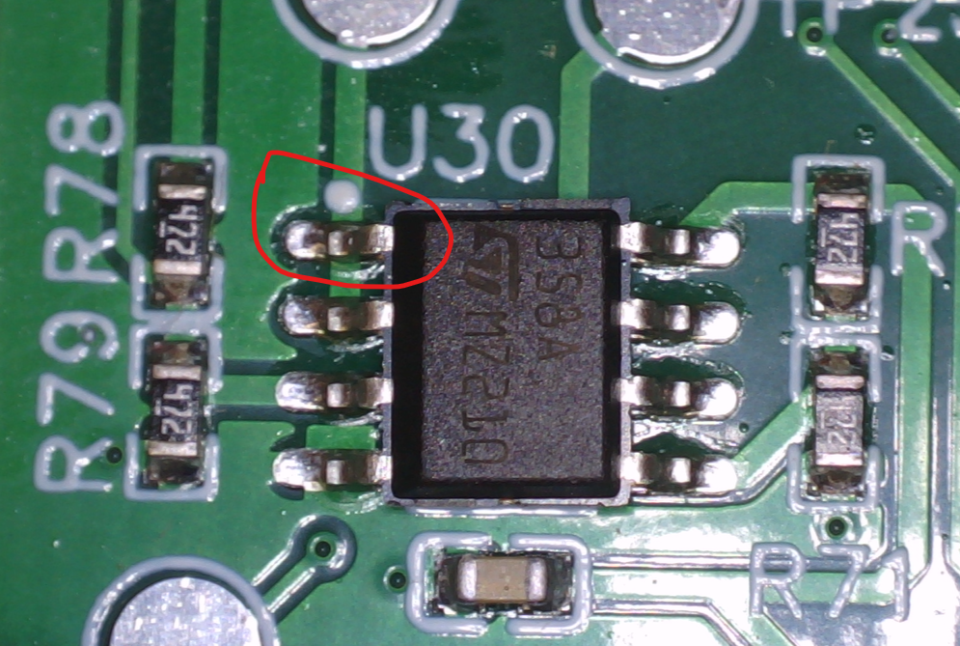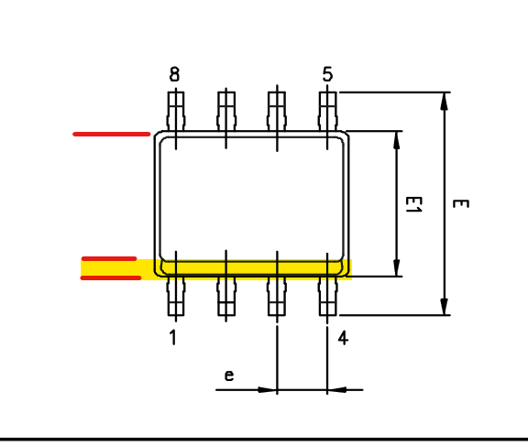 | OK
Lable | Lable of PCB under visual inspection |  |  | 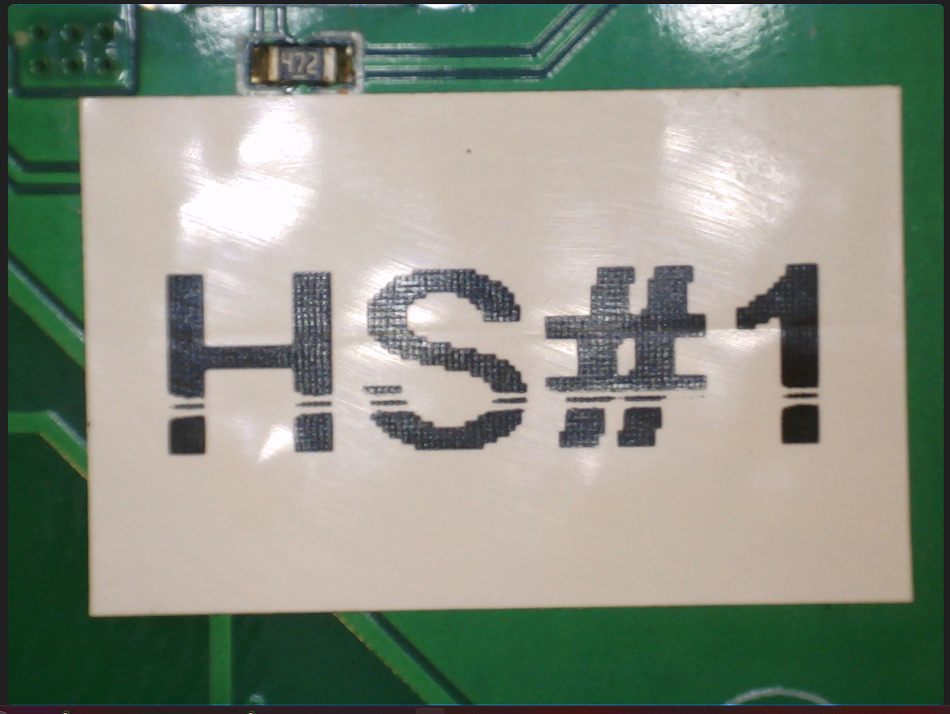 | OK

HS#2 PCB is inspected visually according to the table above without depicting.

2.2 Shorts and resistance measurement (BCH)
Test equipment:
  - Multimeter Please, specify the model
Resistance measurement to be performed on to powered off unit according to the table below.
Signal name | Meas. point | Expected value | Actual value | Status
Q33_6 | BT6 vs GND | >1k | Over Load | OK
Q3_2 | BT5 vs BT6 | >1k | 12.3M Ohms | OK
Q3_2 | BT5 vs GND | >1k | 15.2M Ohms | OK
VBAT | BT3 vs BT6 | >1k | 14M Ohms | OK
VBAT | BT3 vs GND | >1k | 82k Ohms | OK
VIN | Left side of R1 vs GND | >1k | Overload | OK
+5V | TP31 vs GND | >1k | 8.16k Ohms | OK
+3V3 | TP30 vs GND | >1k | 8.55k Ohms | OK
-5V | TP29 vs GND | >1k | 230k Ohms | OK

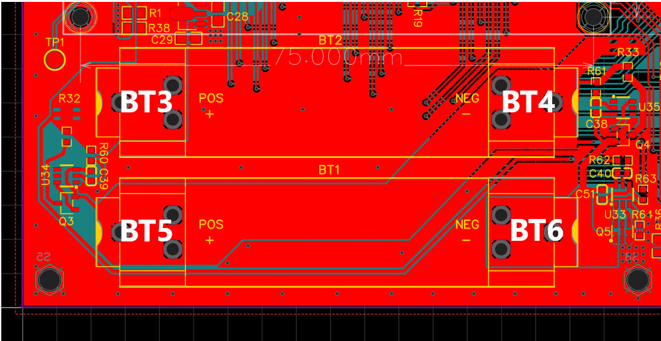

2.3 Power up and voltage measurement

Test equipment:
  - Multimeter Please, specify the model
  - lab power supply / 9V wall adapter CUI SWH15-9-EB-P5

Issue E1 is detected when inserting the batteries.
Suggested temporary solution: Solder shorting 0 Ohm resistors R1 and R38. Wire can be soldered instead of this resistors. Apply 9V input power to the CON1 with 100mA current limit if possible.
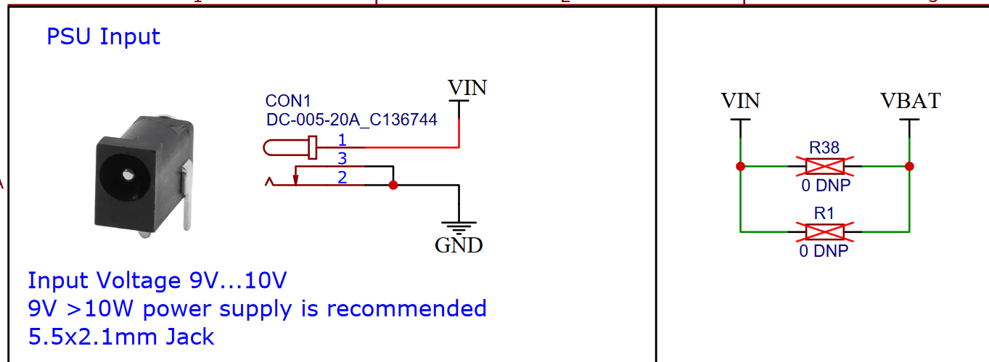

Voltage rails measurement when powered by wall adapter
Rail name | Meas. point | Expected value, V |  |  | Ref. | Actual value BCH#1 | Actual value HS#1 | Status
Rail name | Meas. point | Min. | Nom. | Max.
VIN | R1 left side vs GND | 8 | 9 | 10 |  | 9.01 |  | OK
VBAT | R2 right side vs GND | 4 | 7.5 | 9 |  | 7.32 |  | OK
+5V | TP31 vs GND | 4.5 | 5 | 5.5 |  | 4.98 | 4.987 | OK
+3V3 | TP30 vs GND | 3.0 | 3.3 | 3.5 |  | 3.26 | 3.312 | OK
-5V | TP29 vs GND | -5.5 | -5 | -4.5 |  | -4.8 | -4.849 | OK
+1V65 | TP27 vs GND |  | 1.65 |  |  | 1.62 | 1.660 | OK
+2V5 | TP25 vs GND |  | 2.5 |  |  | 2.48 | 2.496 | OK

Set status as OK if measured voltage is within the expected values range.

3. Functional blocks verification

3.1 Bilevel Converter Module

Evaluating BiLevel converter and transform to make signals go between -5 and 5 volts to toggle MUX ICs.
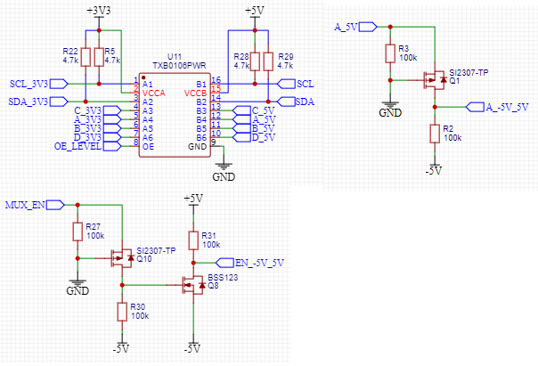

Rail name | Meas. point | Expected value, V |  |  | Ref. | Actual value | Status
Rail name | Meas. point | Min. | Nom. | Max. | Ref. | Actual value | Status
A in | A_3V3 vs GND |  | 3.3 |  |  | 3.34 | Ok
A shifted | A_5V vs GND |  | 5 |  |  | 4.37 | Ok
A -5_5 | A_-5V_5V vs GND |  | -5 and 5 |  |  | -4.75 and +4.35 | Ok
MUX in | MUX_EN vs GND |  | 3.3
MUX_EN -5_5 | EN_-5V_5V vs GND |  | -5 and 5
OE enb | OE_LEVEL vs GND |  | 3.3 |  |  | 2.77 | High enough to work, but odd its so low.

Everything appears to be functional with this module.

3.2 MUX

3.2.1 RJ45 wire pin out
In order to verify the MUX, the RJ45 pin out diagram is required. Such diagram is provided below.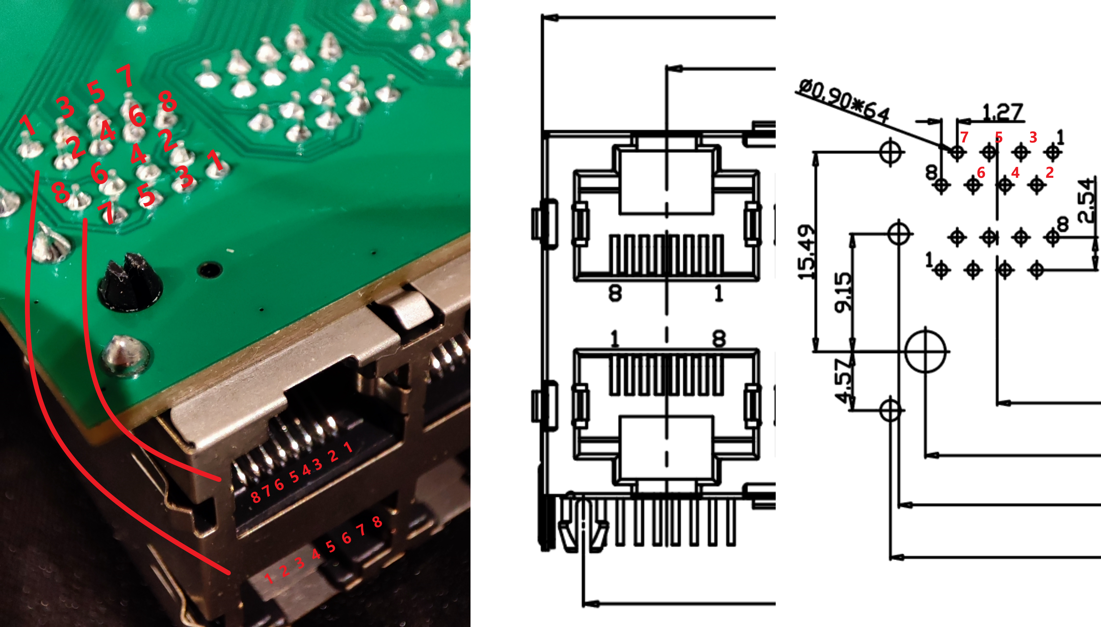 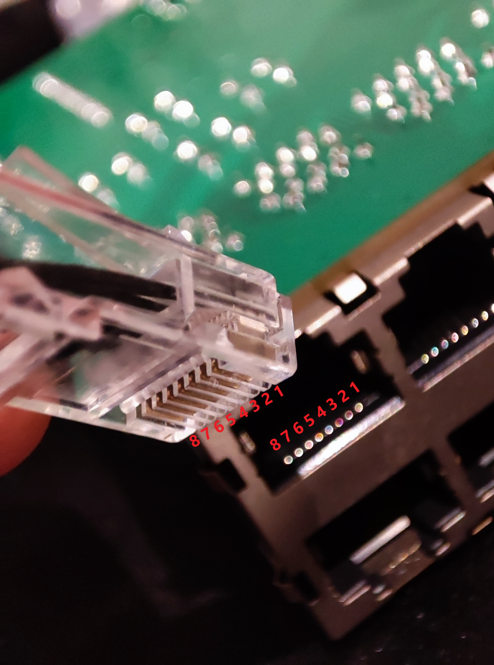 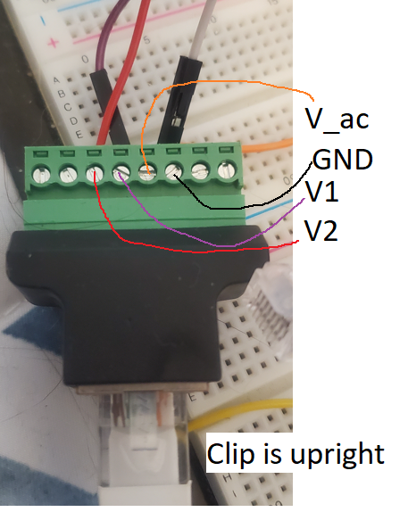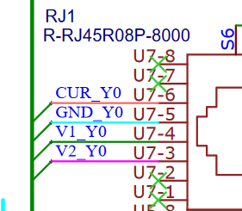

3.2.2 MUX verification
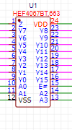

Resistance Measurements
Meas. point | Expected Value, Ω | Measured Value | A | B | C | D | Status
Y0 vs Z | 0 | 0 | LOW | LOW | LOW | LOW | Ok
Y1 vs Z | Over Load | Over Load | LOW | LOW | LOW | LOW | Ok
Y4 vs Z | 0 | 0 | LOW | LOW | HIGH | LOW | Ok
Y10 vs Z | Over Load | Over Load | LOW | LOW | HIGH | LOW | Ok

MUX enable, a,b,c,d pins appear to function properly. Channels are switching to proper channels given A,B,C,D logic inputs.

3.3 AC Generation

3.3.1 DAC test
Arduino defaults to 8bit for DAC. Hardware is 10bit so I added in a code line to make it 10bit input. I put a 12k resistor in as a sub for ‘cell load’ and ran it at around 12Hz (the target frequency) and it worked very well. I believe this module is functioning very well and super close to simulation predictions. Here is a conversion chart between DAC and the ADC on pins A0 and A2 respectively. 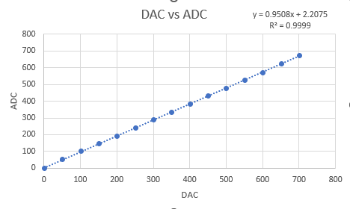

NOTE. DAC output voltage on Arduino 3V3 IOT is limited to the 2.274V <=> approx 700 counts
Link to the article on Arduino forum

Internal DAC output voltage
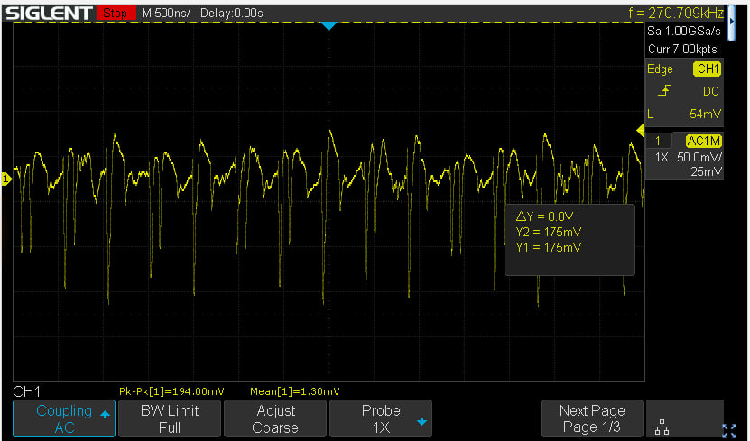
3V3 voltage AC measurement
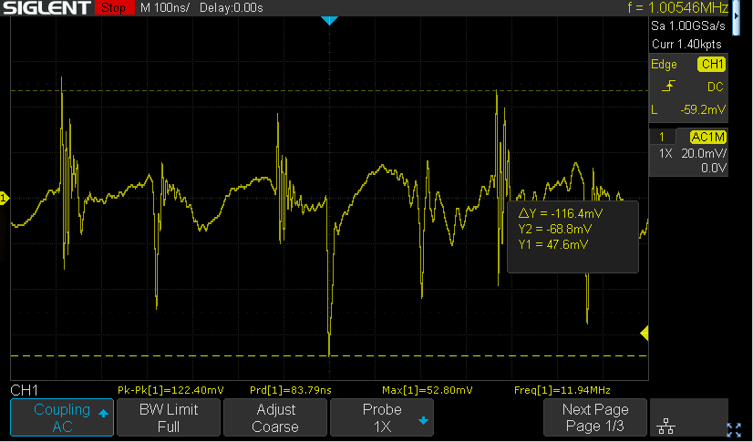

Internal DAC ouput voltage is very noisy as it’s supplied from the Arduino on-board switching power supply. There is no way to provide external clean 3V3 rail to Arduino. Therefore we decided to use external DAC. See the E19 remark

External DAC output voltage:
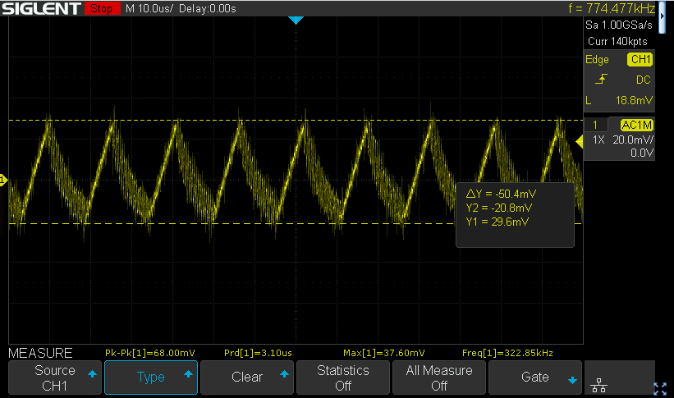
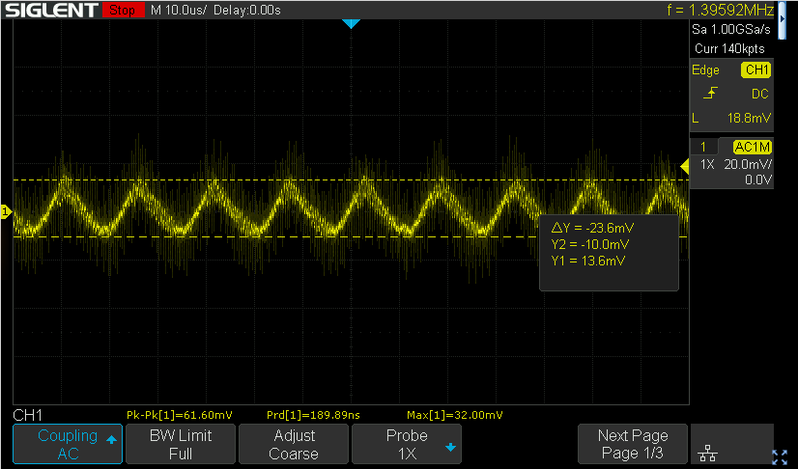
LDO Vout when Arduino is removed (HOT)
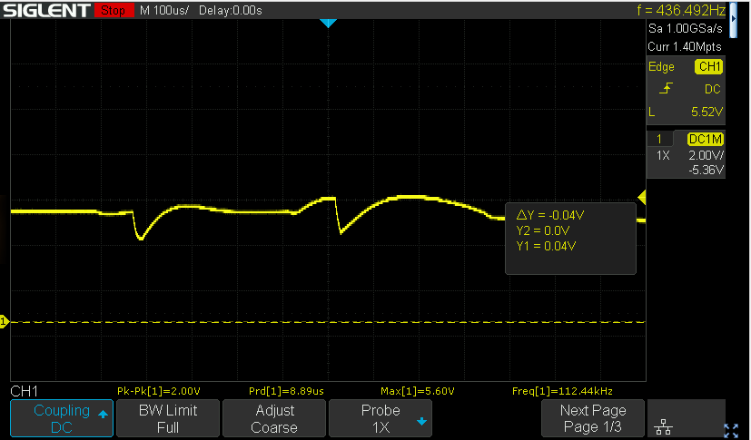
LDO becomes highly unstable...
This is caused by the opamps supplied only from one side (5V is provided, -5V is suddenly removed). No issue with LDO stability here. See the E21 remark
LDO noise measured with the spring directly on the LDO output cap
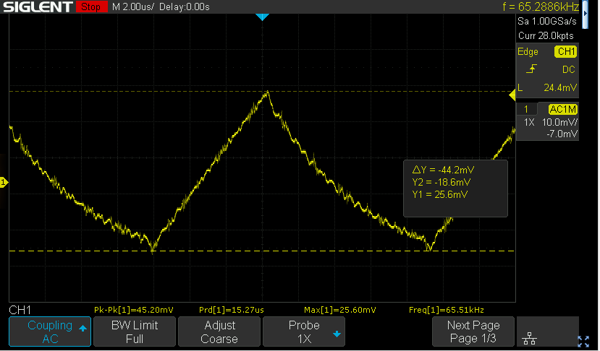
Additional 4.4uF + 220nF to the output. Same cursors as above:
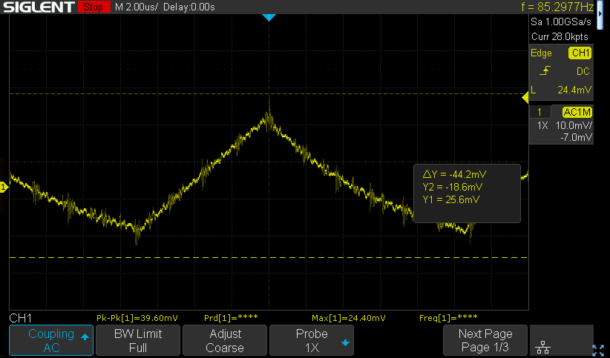
Changed the LDO to NCP730
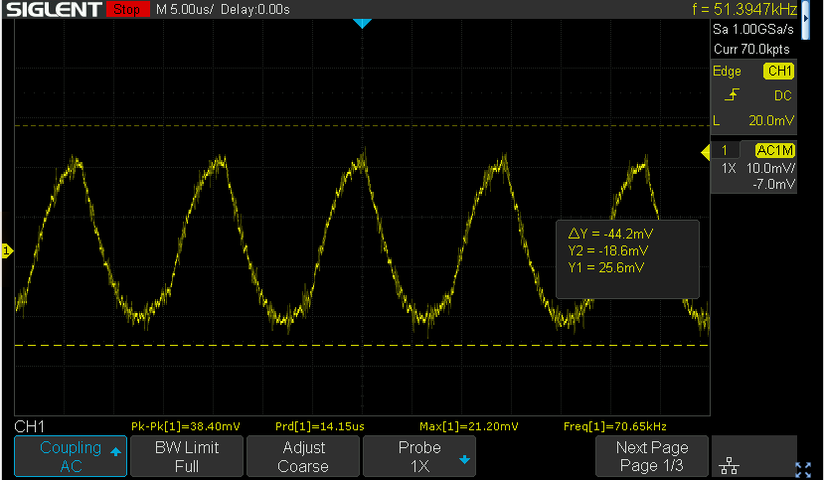
Iout (voltage set to 0.723)
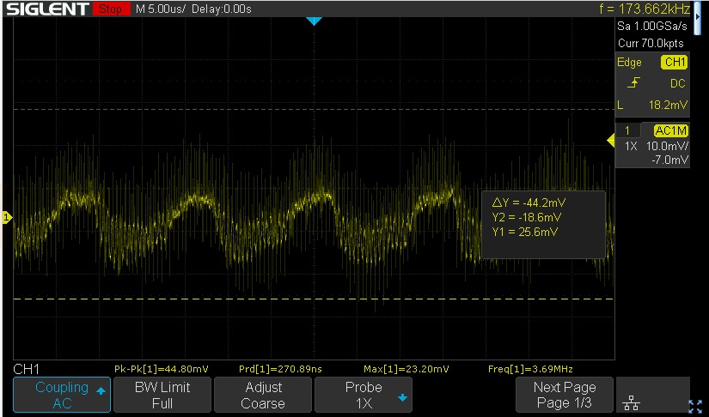
Changing the LDO to another one has no impact on the 5V rail noise. This means that one of the consumers on this line is introducing noise into it. Not the LDO “ringing”. The most suspicious load connected to 5V rail is the -5V generator charge pump. In order to check it’s influence on the 5V rail it’s decided to try and supply it from separate 5V LDO according to the following picture
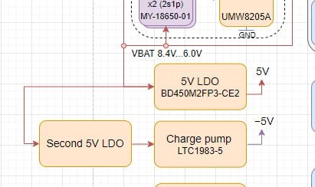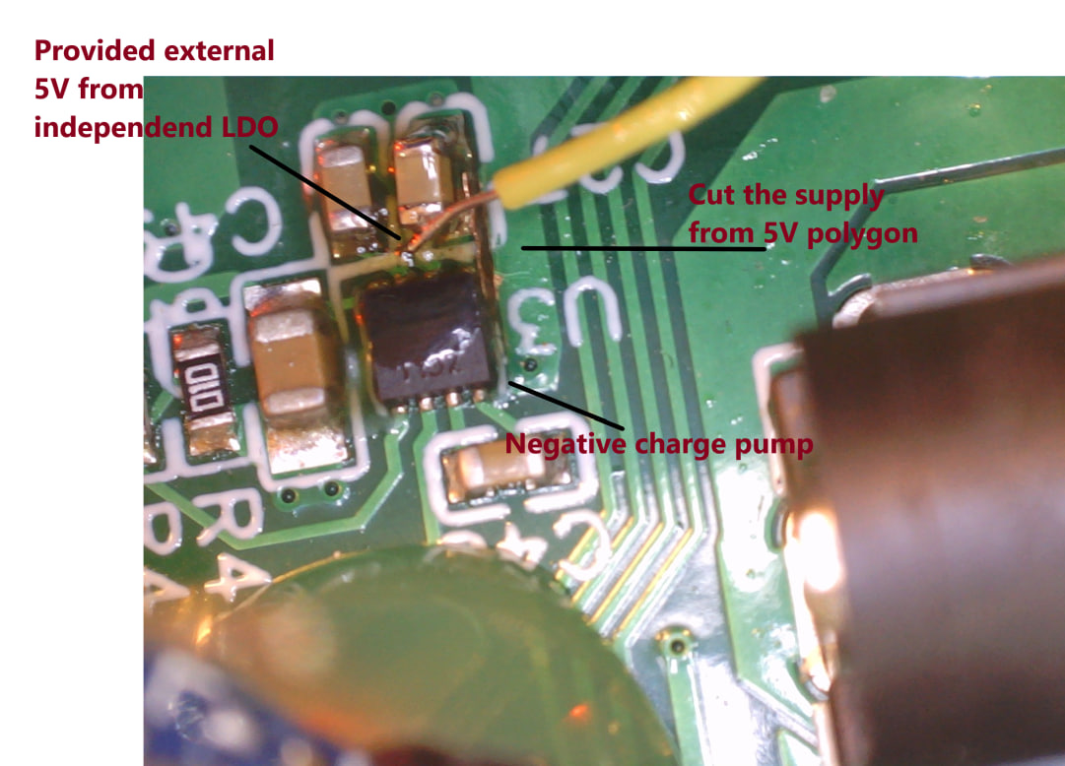

DAC output voltage after supplying the Charge pump from separate 5V LDO
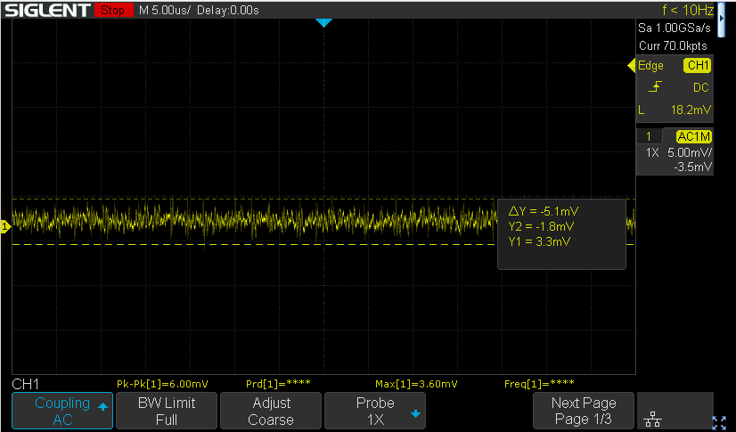
DAC Vout @ 3.11 V output voltage
Vout with multimeter 3.109V
Vout with scope DC:
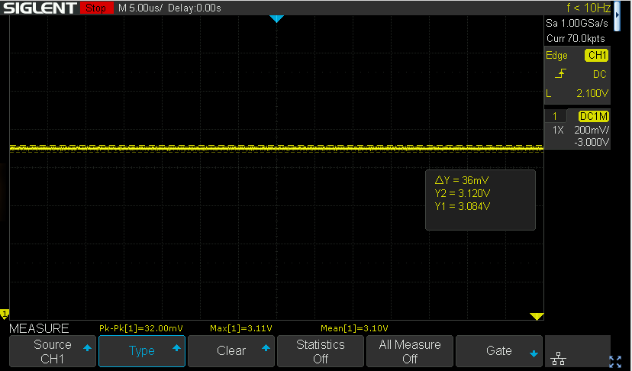
Vout with scope AC:
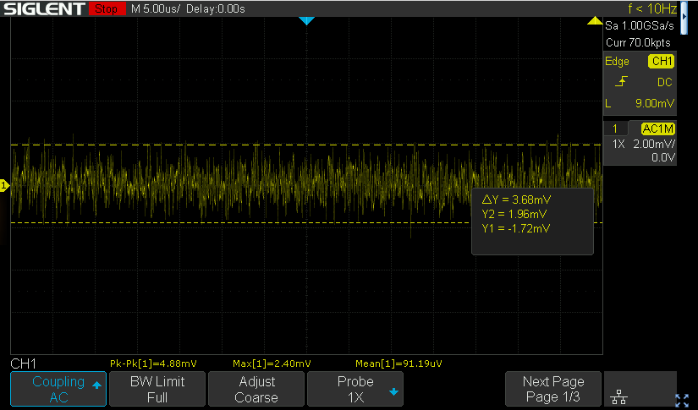
5mV pk-pk
At this point I would conclude the DAC performance as good enough and continue checking other circuits

3.3.2 Current generator test
The circuit name is the Improved Hawland Current Pump
Supporting documentation:
-Analysis of Improved Howland Current Pump Configurations

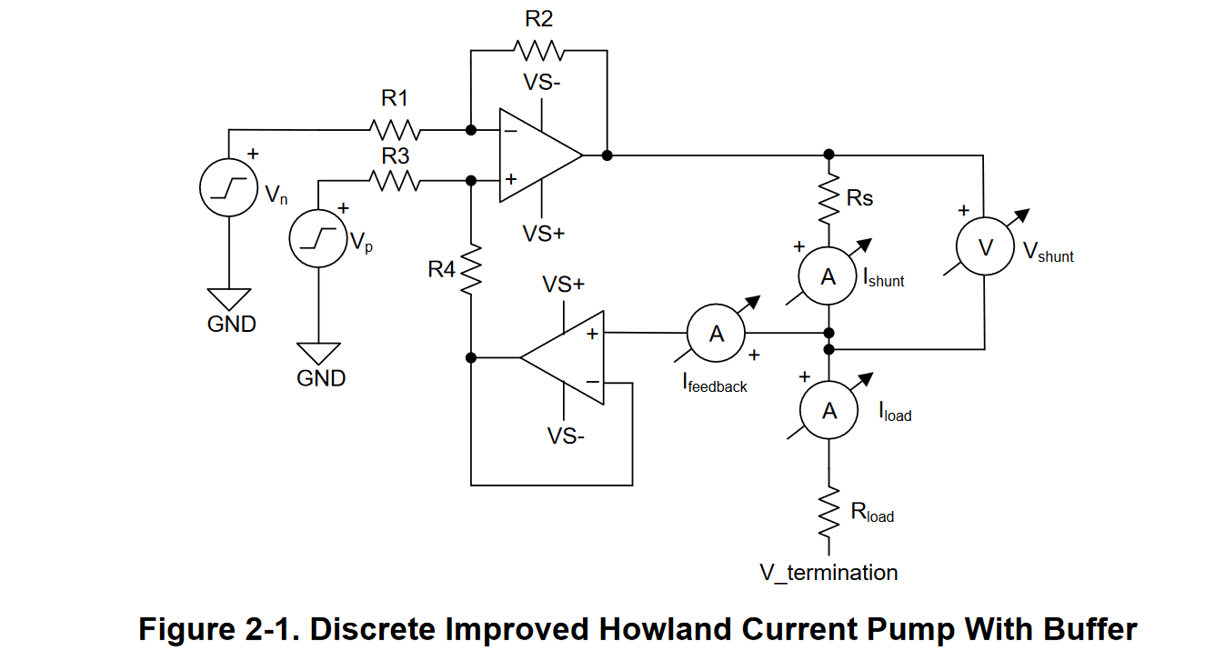
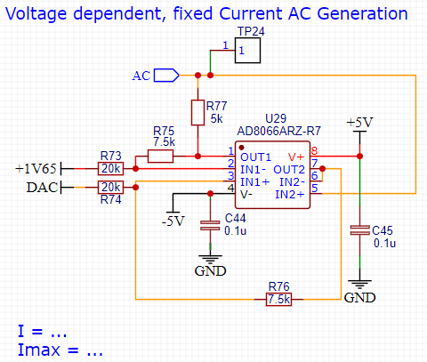

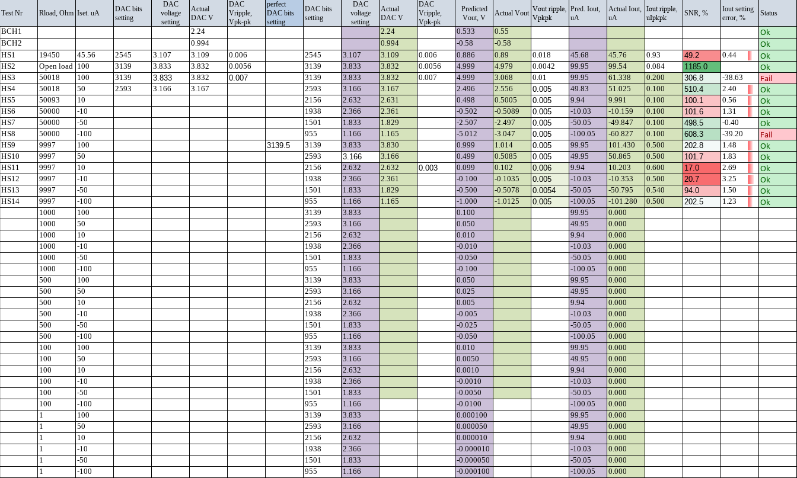
Measurement point: TP24 vs GND

Expected output voltages range:

Res\current | 0.0001 | 0.00005 | 0.00001 | -0.00001 | -0.00005 | -0.0001
50000 | 5 | 2.5 | 0.5 | -0.5 | -2.5 | -5
10000 | 1 | 0.5 | 0.1 | -0.1 | -0.5 | -1
1000 | 0.1 | 0.05 | 0.01 | -0.01 | -0.05 | -0.1
500 | 0.05 | 0.025 | 0.005 | -0.005 | -0.025 | -0.05
100 | 0.01 | 0.005 | 0.001 | -0.001 | -0.005 | -0.01
1 | 0.0001 | 0.00005 | 0.00001 | -0.00001 | -0.00005 | -0.0001

Resistor 1:
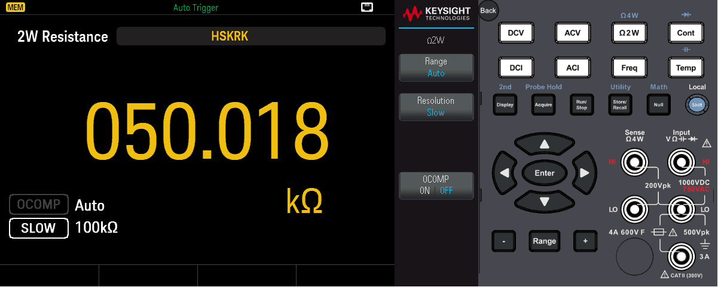

Functional test and oscilloscope measurement screen shots:

Here is proof I generated a symmetric AC wave through the 12k resistor. Looks great! (values of 426 and 626 were used as 1.62V (the ref voltage) was projected to be 526).

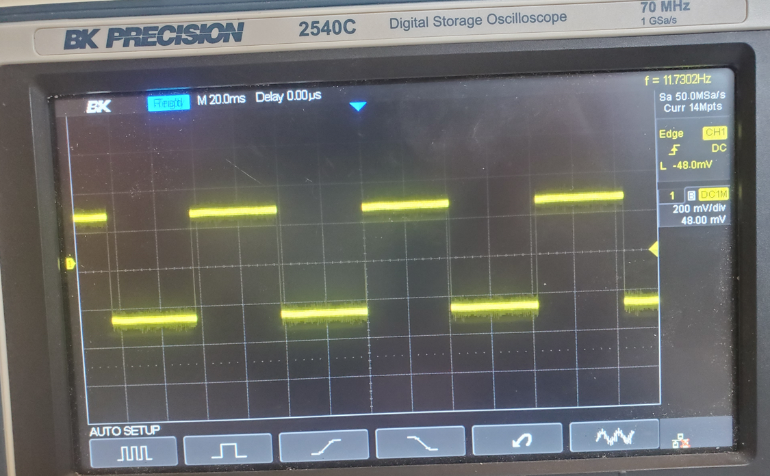

Measurements on the HS site.
Pictures 1-3: Initial measurements (DAC noise correction is not implemented)
Picture 4: DAC output noise improvement
no load  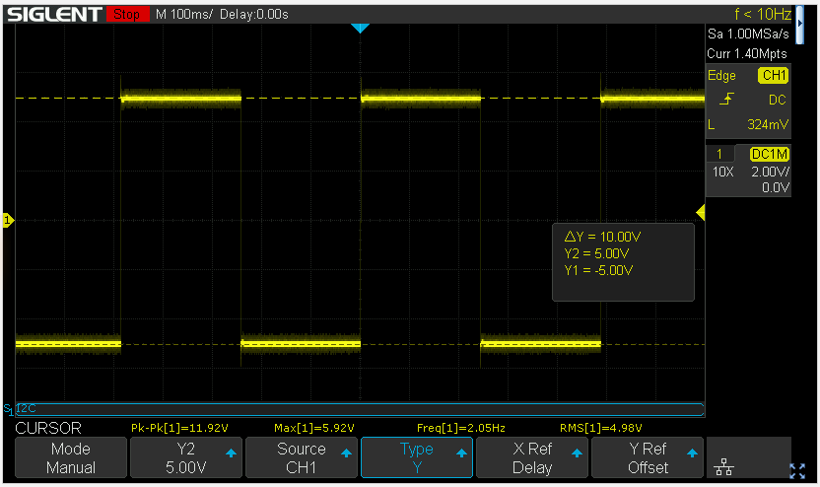 | 524 Ohm connected (501.73 true value)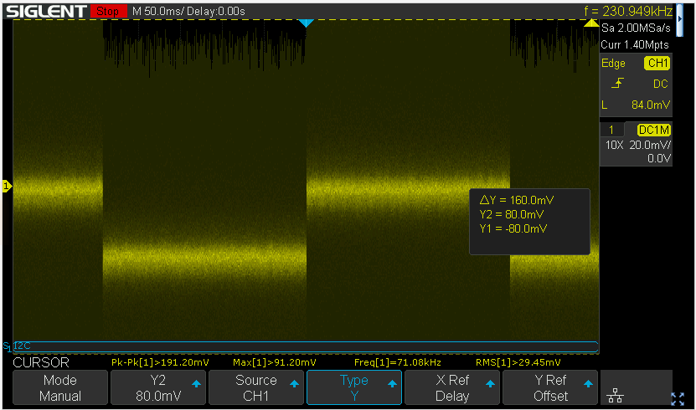
21.5 kOhm (19.587 k Ohm true value)  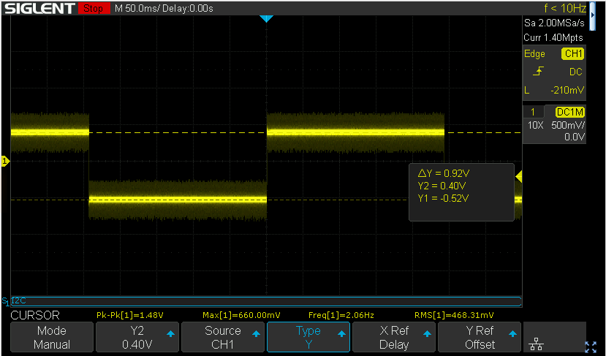 | Vout on the resistor after DAC voltage fix 5mV pk pk  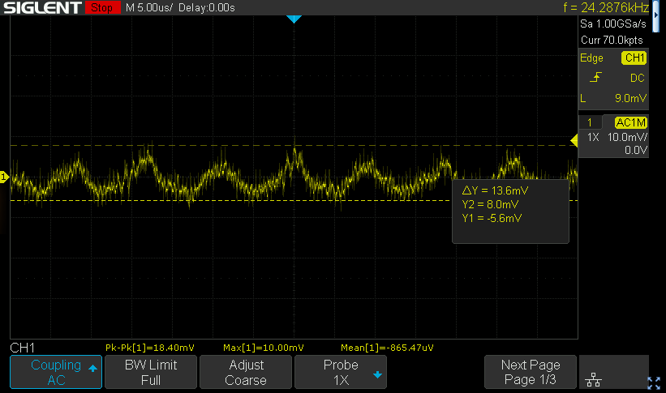

-5V power supply in AC mode
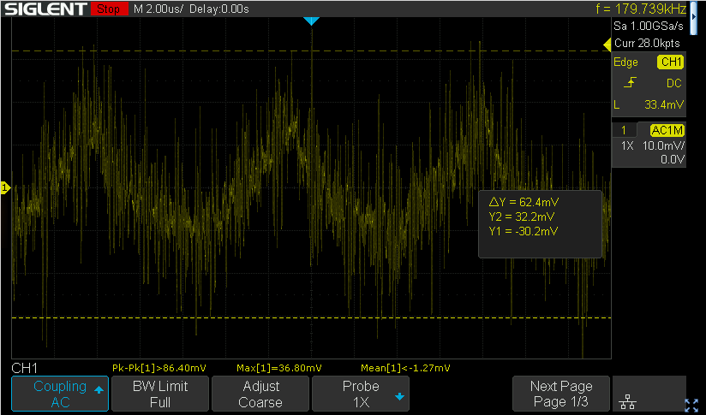

5V power supply
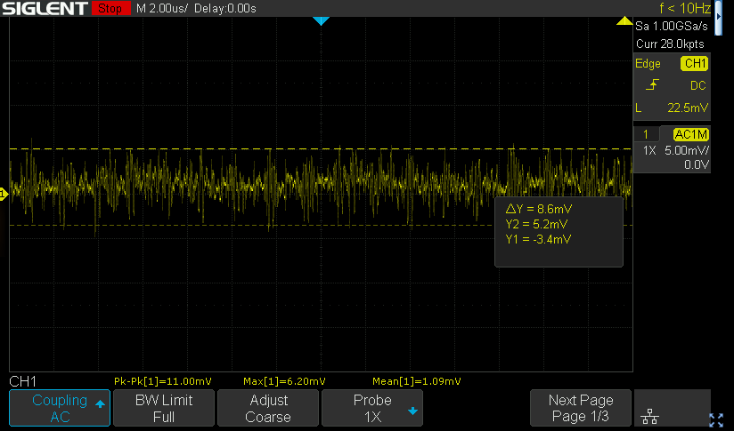

Vout in DC mode expected 0.874
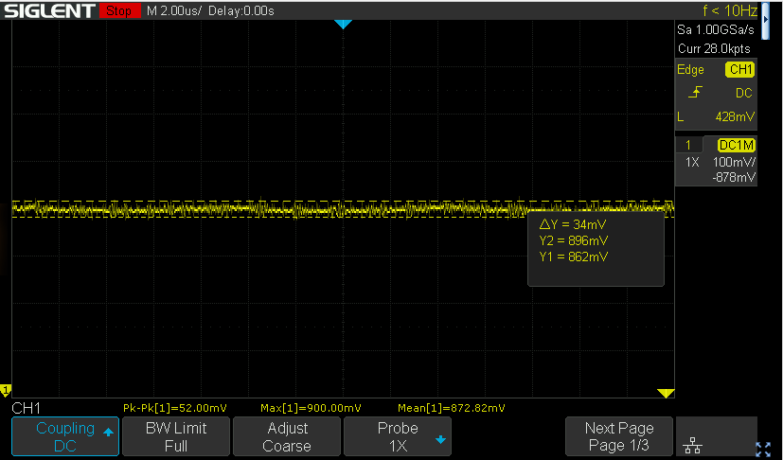

10 uA output set current
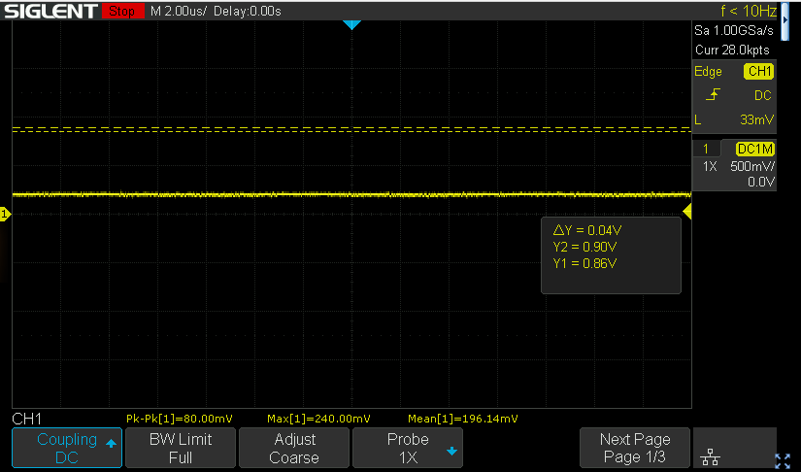

Vac with -5V supply improved (light load mode removed)
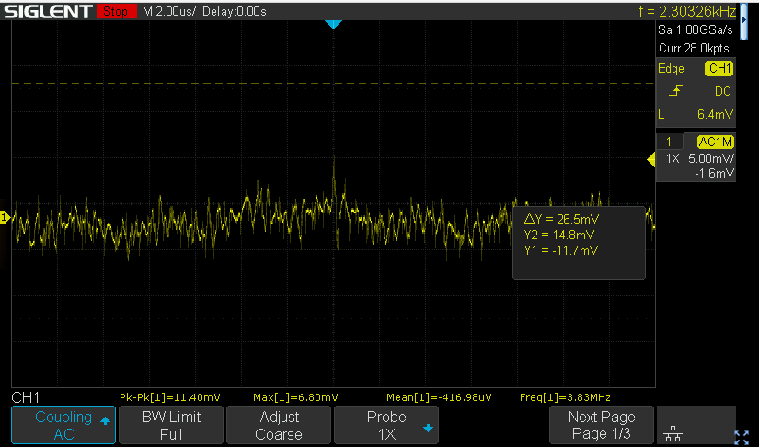
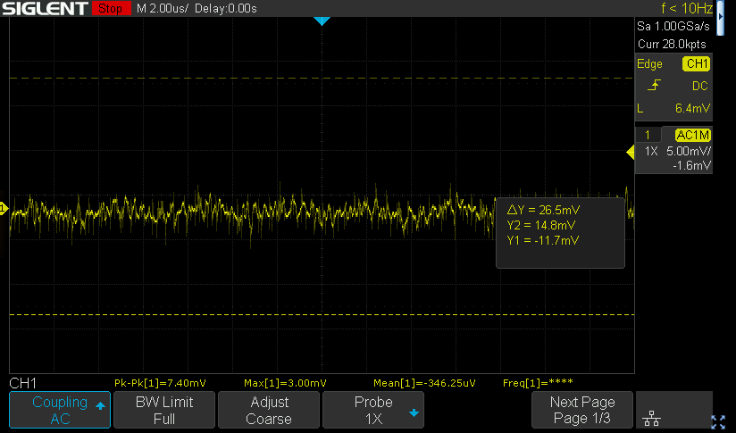

-5V supply noise improvement
Initial Vout AC
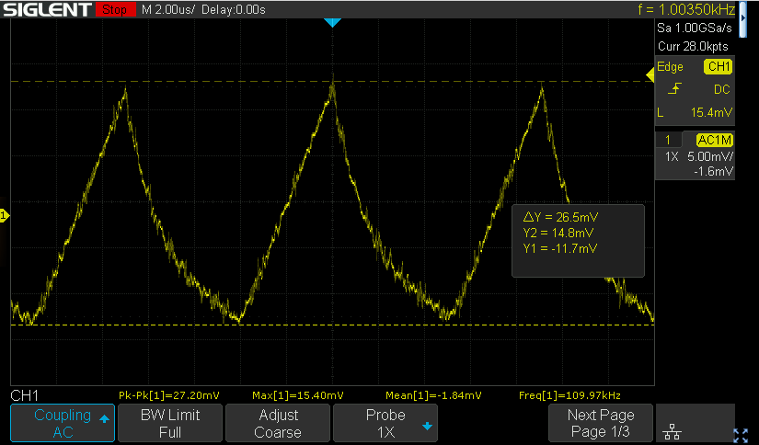
-5V vout with additional 150 Ohm drain resistor (242 Ohm – minimum resistance found with potentiometer to exit the pulse skipping mode. I will add 220 Ohm as temporary fix for future measurements)
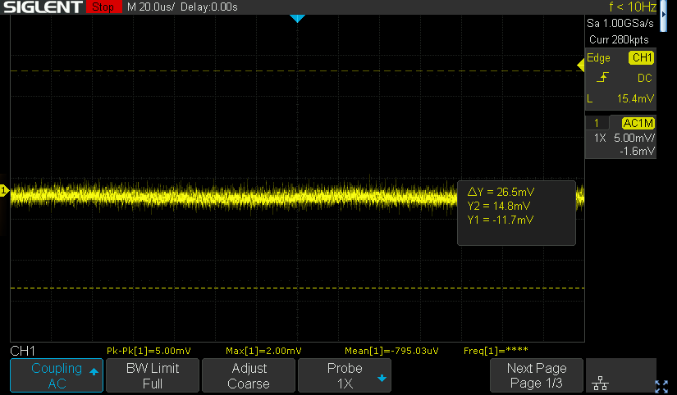
Display is connected
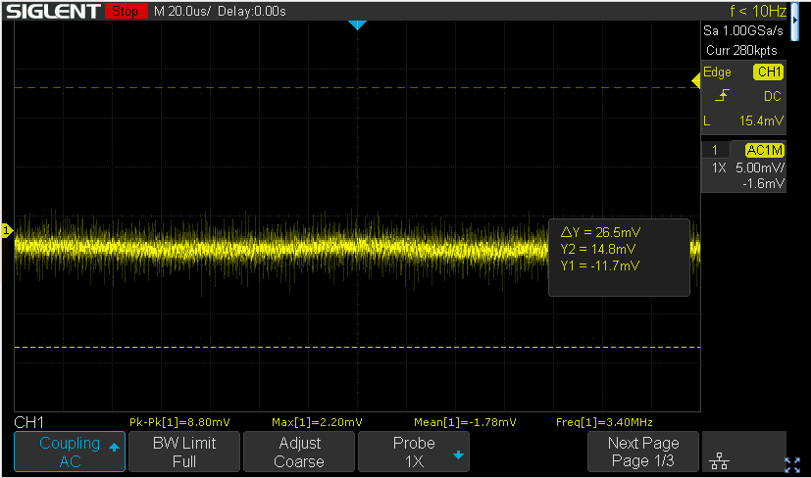
Additional Caps 10u+1u+22n for LCD display
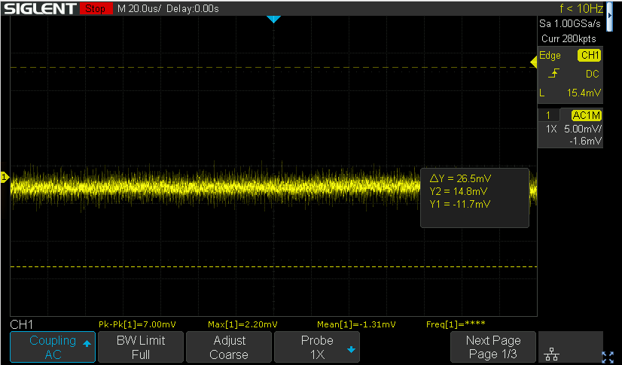
220 Ohm load -5V line AC
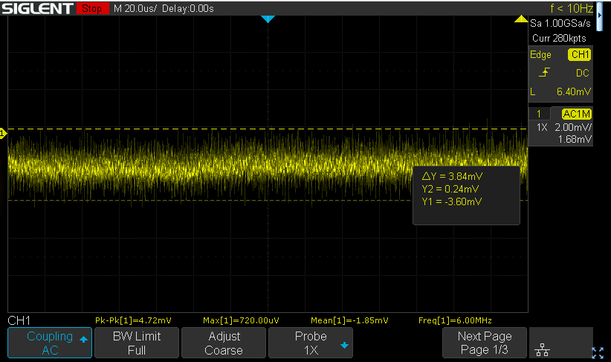
After some time passed
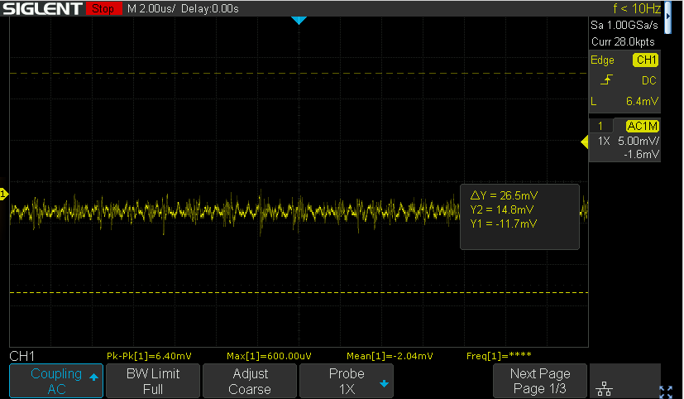
-5V supply in DC mode
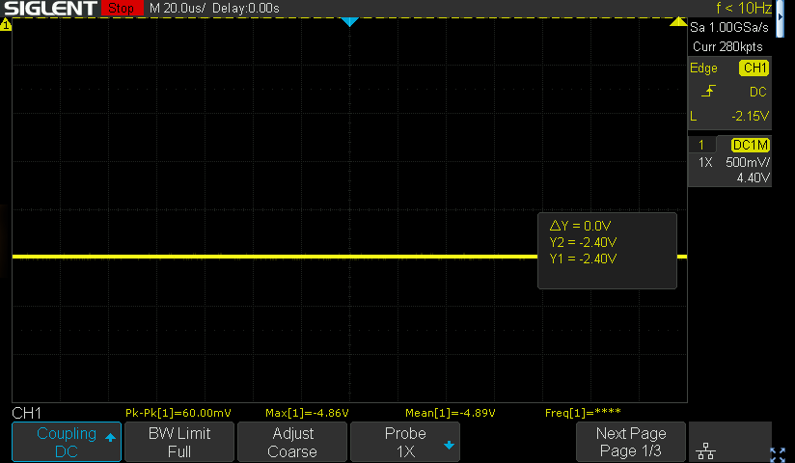
Related discussions on TI forum:
Pulse skipping mode: link
Input voltage: link

3.4 Battery power and charging

In order to use the Rev.2 hardware in battery powered mode the folliwing sequence must be followed:
- Insert the spacer between the batteries to avoid shorting them to eachother
- Insert the arduino module
- Insert the batteries. Lower battery goes first. Upper battery is the second.
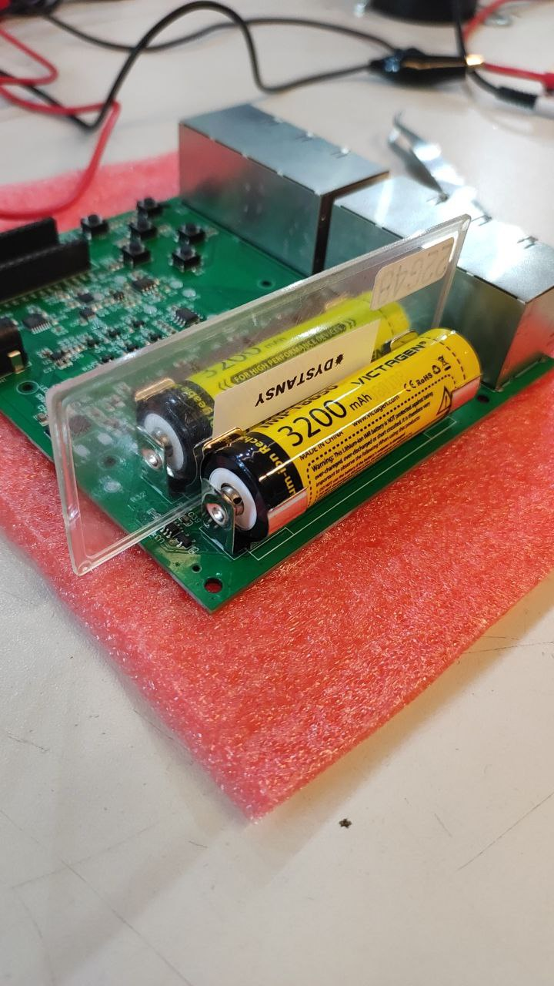
- Insert the 9V power supply to start the batteries charging.
Now the charger can be removed and the module can be used powered purely by the batteries.

DON’T USE BATTERIES AT THE SAME TIME WITH THE POWER SUPPLY IF R1 R38 SHORT IS INSTALLED

Battery power will not work until the charger is connected
Batteries charging stops at:
Expected:
Measured:

Batteries charging current:
Expected:
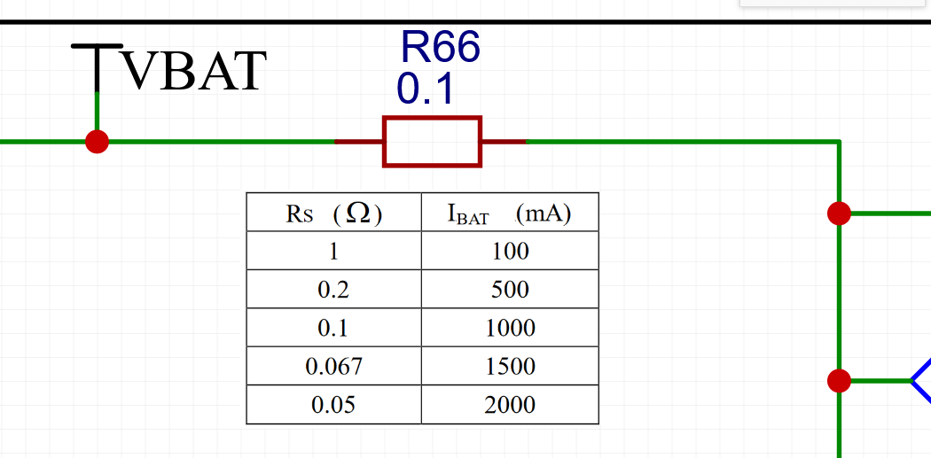
Measured:

Power supply architecture improvement:

3.5 Batteries balancing circuit

3.6 Voltage Processing Instrumentation and Differential Amps

Ideas for testing:
Advanced measurements:
- Transfer function
- Input offset current / voltages
- Input bias current
- CMRR / DMRR
- Input impedance
Basic measurements:
- Amplification of the signal generated by AC gen circuit
- Amplification of the voltage from resistor divider as an input (preference)
Amplification of the voltage from buffered resistor divider as an input

3.6.1 Amplification of the signal generated by AC gen circuit
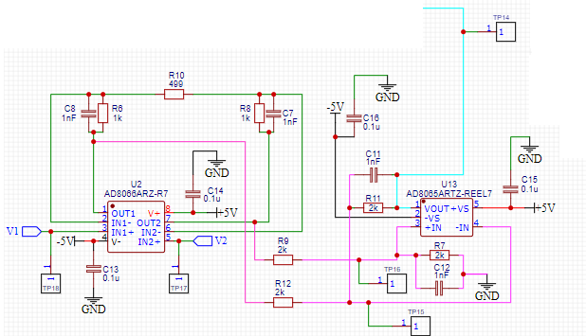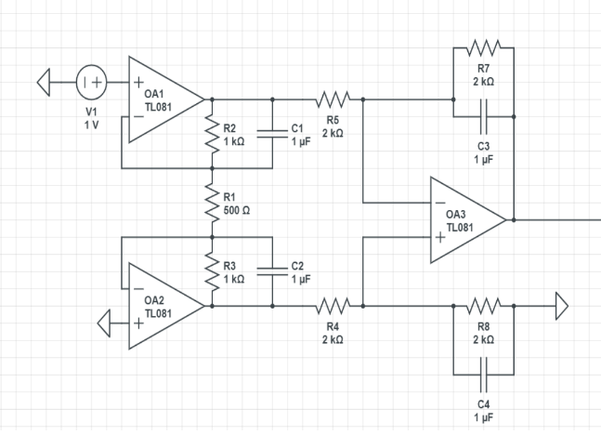

This module samples very low amounts of current from two points with voltages V1 and V2, it then finds the difference between and multiplies it by a gain factor of 5.

Sample: BCH#1
Test equipment:
        - To be filled
Test software:
        - pre_adc_voltage_processing_testing_code.ino

Vdac1 = 3.3 V1024·426 = 1.37 V
Iout1 = 7.420·(Vdac1 − Vref)R = 7.420·(1.37 V − 1.65 V)5000 Ω = -2.05×10-5 A
udac1 = 1500 Ω·Iout1 = 1500 Ω·(-2.05×10-5 A) = -0.0308 V
udac12 = 470 Ω·Iout1 = 470 Ω·(-2.05×10-5 A) = -0.00964 V

Vdac2 = 3.3 V1024·626 = 2.02 V
Iout2 = 7.420·(Vdac2 − Vref)R = 7.420·(2.02 V − 1.65 V)5000 Ω = 2.72×10-5 A
udac2 = 1500 Ω·Iout2 = 1500 Ω·2.72×10-5 A = 0.0408 V
udac22 = 470 Ω·Iout2 = 470 Ω·2.72×10-5 A = 0.0128 V

Measurement | Meas. point | Resistor Sample, Ohm | Expected value, mV | Actual value, mV | Status
V1 | TP18 vs GND | 1500 | -11.1 | -11.1 | Ok
V2 | TP17 vs GND | 1500 | -195.7 | -195.8 | Ok
U13 pin 3 | TP16 vs GND | 1500 | 179.2 | 180.3 | Ok
(V1-V2)*gain | TP14 vs GND | 1500 | 923.5 | 928.0 | Ok
V1 | TP18 vs GND | 470 | -11.1 | -11.1 | Ok
V2 | TP17 vs GND | 470 | -69.5 | -69.5 | Ok
V1 – V2 | TP16 vs GND | 470 | 53.0 | 53.9 | Ok
(V1-V2)*gain | TP14 vs GND | 470 | 292.5 | 298.0 | Ok
Works very well and right with simulations.

Sample HS#1
Res\current | 0.0001 | 0.00005 | 0.00001 | -0.00001 | -0.00005 | -0.0001
50000 | 5 | 2.5 | 0.5 | -0.5 | -2.5 | -5
10000 | 1 | 0.5 | 0.1 | -0.1 | -0.5 | -1
1000 | 0.1 | 0.05 | 0.01 | -0.01 | -0.05 | -0.1
500 | 0.05 | 0.025 | 0.005 | -0.005 | -0.025 | -0.05
100 | 0.01 | 0.005 | 0.001 | -0.001 | -0.005 | -0.01
1 | 0.0001 | 0.00005 | 0.00001 | -0.00001 | -0.00005 | -0.0001
For HS14 curr gen test
Test Nr | Measurement | Meas. point | Resistor Sample, Ohm | Expected Vout, mV | Actual value, mV | Status
HS14 | V1 | TP18 vs GND | 9997 | 0 | 0.0033
HS14 | V2 | TP17 vs GND | 9997 | -1 | -1.0037
HS14 | (V1-V2) | TP16 vs GND | 9997 | -1 | -1.501 | ?
HS14 | (V1-V2)*gain | TP14 vs GND | 9997 | -5 | -4.999 | ok
HS10 | V1 | TP18 vs GND | 9997 |  | 0.5
HS10 | V2 | TP17 vs GND | 9997 |  | 0
HS10 | V1 – V2 | TP16 vs GND | 9997 |  | 0.753 | ?
HS10 | (V1-V2)*gain | TP14 vs GND | 9997 | 2.5 | 2.505 | ok

3.6.2 Amplification of the voltage from resistor divider as an input
skipped

3.7 ADC Driver
The goal of the driver is to take single ended inputs and make then differential with an offset. The offset we have is VOCM = 2.5V. So
Vnp = 2.5 + input/2
Vnn = 2.5 – input/2.

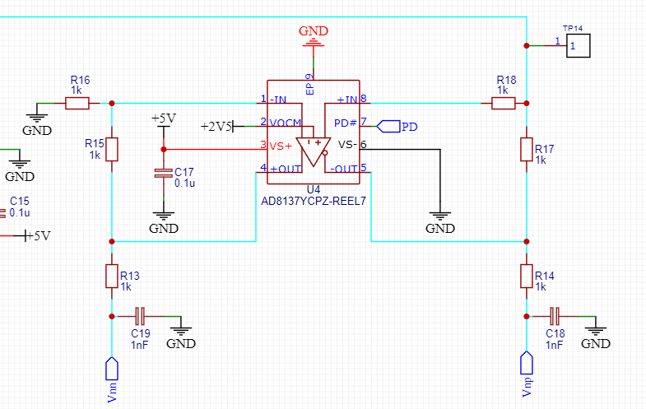
Measurement | Meas. point | Expected value, V | Actual value, V | Status
V diff (input) | TP14 vs GND | 0.3 | 0.3 | OK
Vnp (output) | R14 vs GND | 2.63 | 4.65 | NOK
Vnn (output) | R13 vs GND | 2.33 | 0.28 | NOK
V diff | TP14 vs GND | 0.17 | 0.17 | OK
Vnp | R14 vs GND | 2.59 | 4.65 | NOK
Vnn | R13 vs GND | 2.41 | .28 | NOK
What is strange here is that 4.65+0.28 = 4.93. That is close to VS+ voltage. ADC is turned on for these measurements too. Does not seem to respond when input is changed.
There is a mistake in the circuit with R17 / R18 connection. This issue is described in E12 remark and fixed with E12 rework.
Test results after the fix:

Test Nr | Measurement | Meas. point | Expected value, V | Actual value, V | Status
HS10 | V diff (input) | TP14 vs GND | - | 2.505 | OK
 | Vnp (output) | TP11 vs GND | 3.7525 | 3.752 | ok
 | Vnn (output) | TP12 vs GND | 1.247 | 1.250 | ok
 | V diff | TP14 vs GND
 | Vnp | TP11 vs GND
 | Vnn | TP12 vs GND

3.8 LCD display

3.8.1 Investigation flow
There were several issues in LCD display debugging. Overall process is demonstrated in the diagram below:
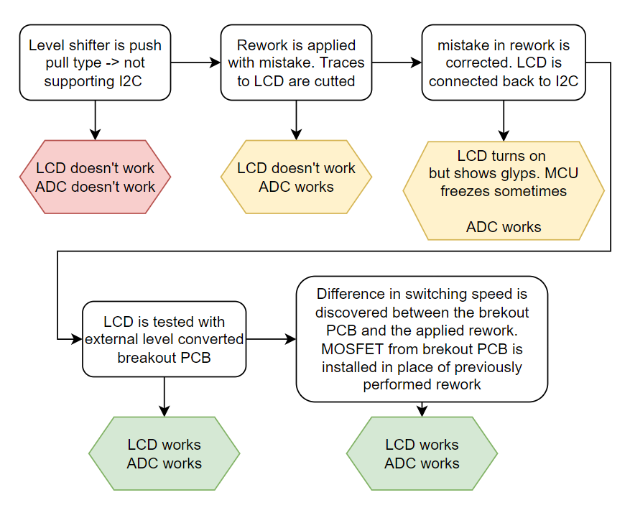
Transistor initially used for the rework: pja94n02 panjit (datasheet)
Transistor that is installed on the brekout PCB: BSS138 onsemi (datasheet)
Difference in parasitic capacitance is order of magnitude:
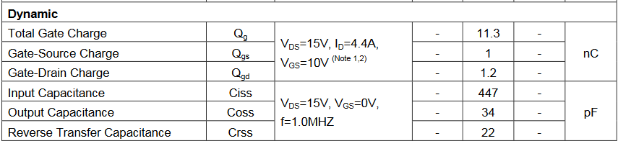

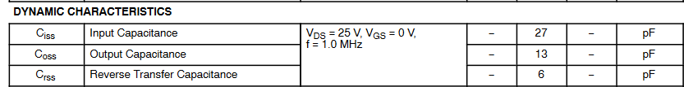

Measured difference in the signal rise time:
Breakout PCB (Yellow – CLK 5V side, Green – CLK 3.3V side, Purple – Data 5V side, Blue – Data 3.3V side)
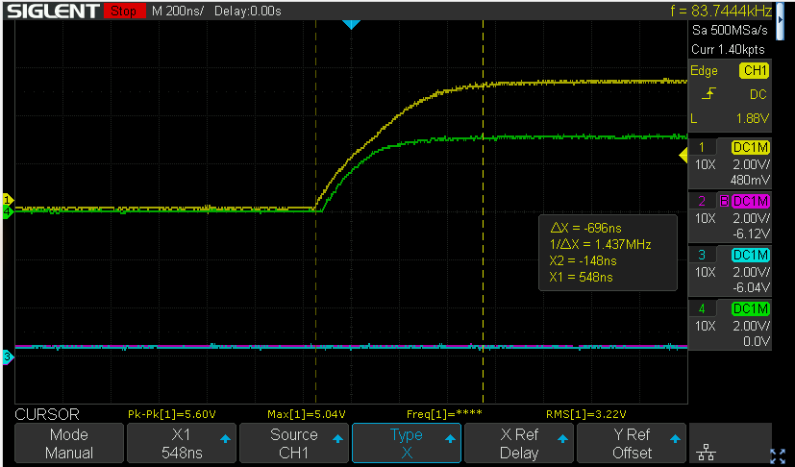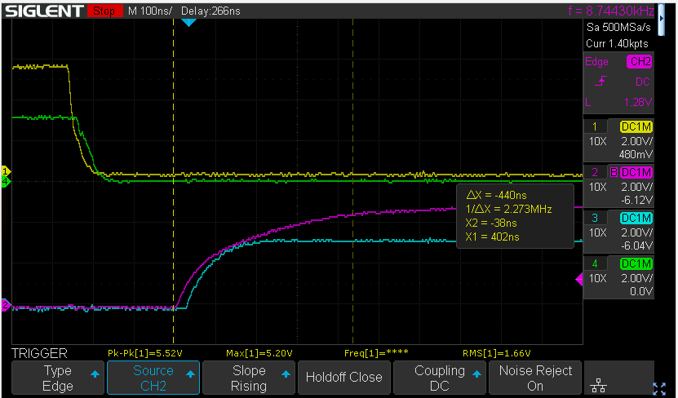
Original rework with slow transistor:
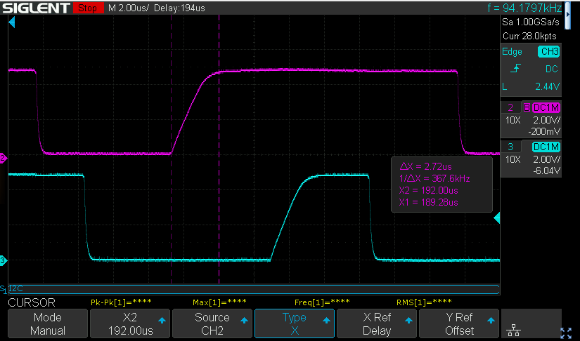

3.8.2 Conclusion
There is no good documentation on the display module timing requirements. But experimentally it’s discovered that the slow rise time for I2C signal is causing glitches with the display. Initial redesign idea was to replace the level shifter with the discreet solution built from MOSFETs. But looking at the fact that not every MOSFET will fit, I prefer to use the IC level shifter in this case. If we will use mosfet, it will need to be tested at every temperature, and every potentiall alternative will need to be tested. IC provides more confidence that the I2C interface will simply work, as all of the edge cases have been already tested by manufacturer

3.8.3 Observation of discreet MOSFETs level shifter operation
There is an interesting feature of the data line observed with both the brakout PCB and my initial rework. This doesn’t create the issue for ADC or LCD function. But the waveform looks unexpected. I have no explanation for this so far.
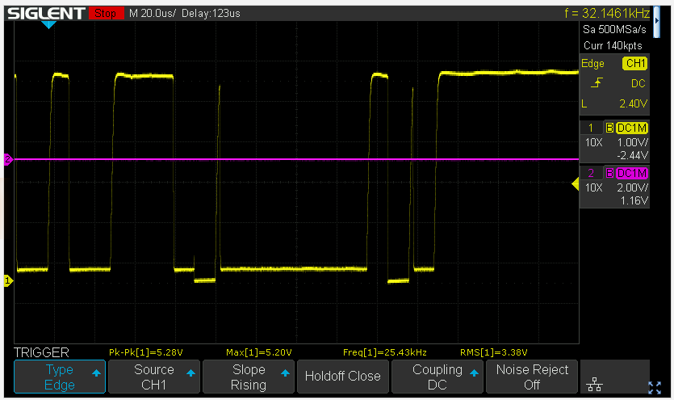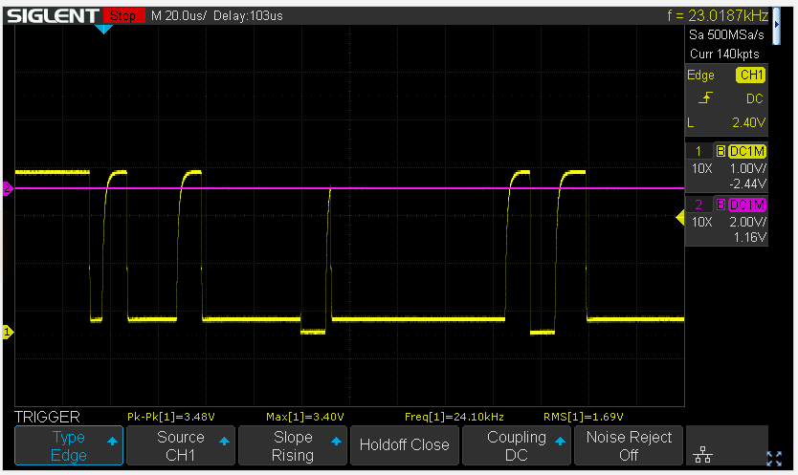
This is the I2C data capture from Arduino Uno where the display module works fine. I see no such glitch on the data line
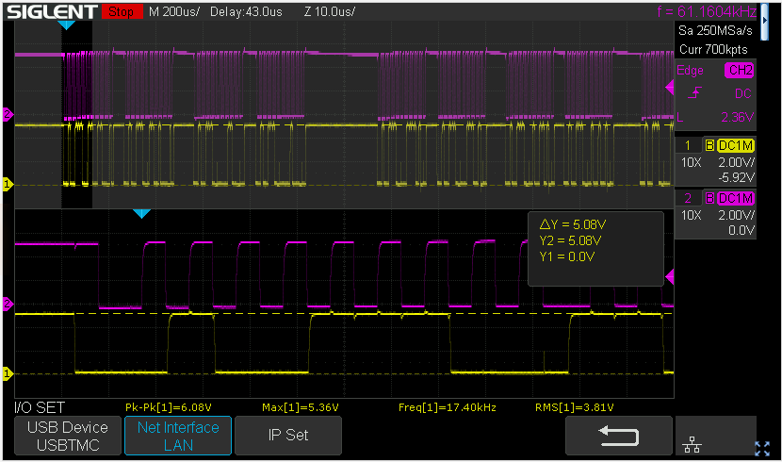

Summary

Assembly issues

No | Issue description | Date/Author | Status
A1 | Low humming coming from bilevel converter. Some outputs (C and A) stuck at 2.3V no matter what 3V3 corresponding input is.  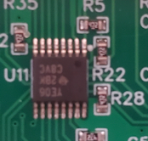  Swapped to different board and noise was not present and bilevel converter worked properly.  Pin 13 looked not soldered properly. Measuring this pin removes the noise. | 15.08.23 MD Anderson | Manual touch up to be applied to pin 13 to fix the prototype  —————-  SCH: No change  PCB: No change
A2

Electronics issues

No | Issue description | Date/Author/priority | Status
E1 | After inserting the second battery the PCB trace starts burning  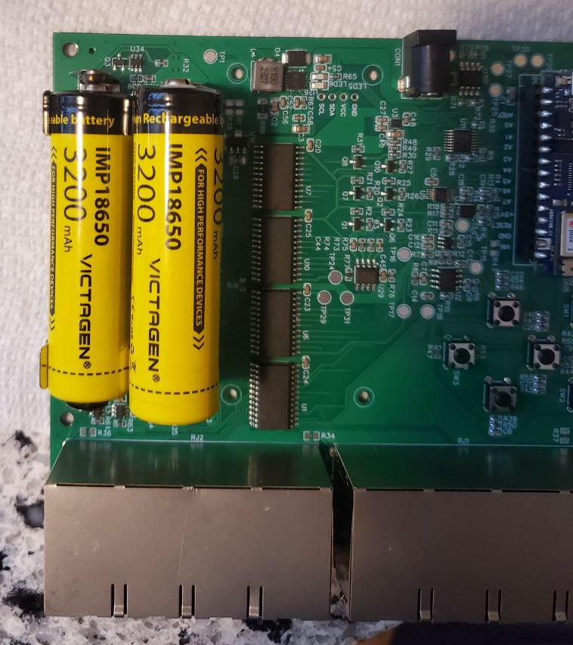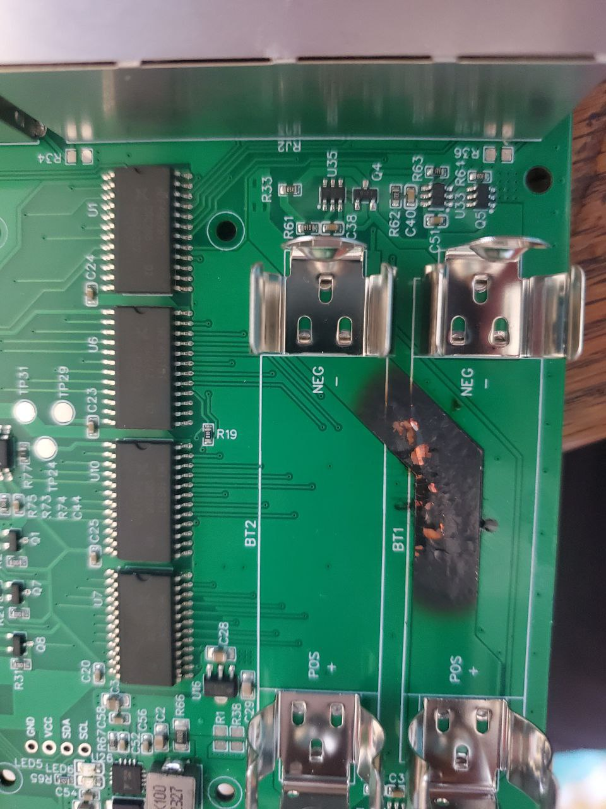  Root cause: When the battery is inserted the battery holder jaws move to the sides, and this causes shorting of the bottom battery | 02.08.23 MD Anderson  High priority | Prototypes are fixed by inserting insulator between the battery holders  --------  SCH: No change  PCB: Spacing between batteries holders to be increased  ToDo
E2 | L4 inductance to be increased to 22uH. Eval board and old datasheet has this value.  L4 MDA7030-100M (C2847485) → MDA7030-220M (C2847487). Pin to pin replacement | 16.08.23 DY  Low priority | 22uH from sample book used on prototypes  SCH: Update L4 value to 22uH per description
E3 | Need to take away aref as the pin for the D_3V3 pin. Even though documentation says it can be a GPIO, it is unclear how to do it. Its easier to modify and use one premapped for that usage.  This pin is not included in the Arduino GPIO library and it can only be used by initializing it on the registers level:  Source  Schematic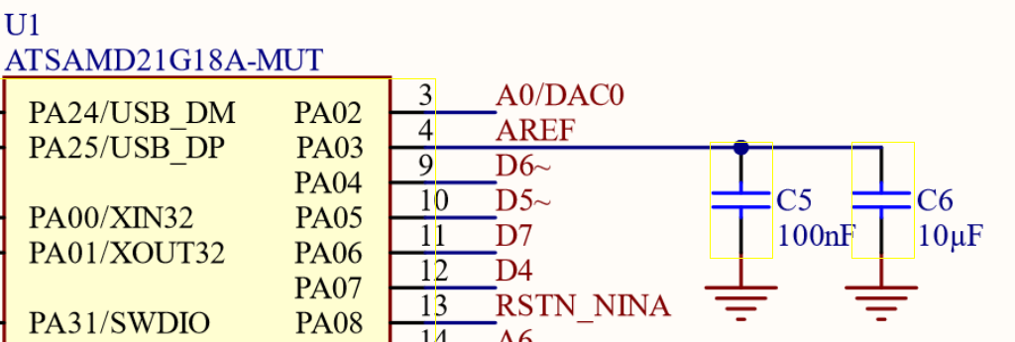  Should be updated in next prototype: we can apply permanent pull up to PD signal, and route the MUX controll signal to A7 pin of the arduino. | 15.08.23 MD Anderson  High priority | Prototypes:  Reworked according to § E3 AREF pin  Not tested  --------  SCH: Pull up PD signal. Use A7 GPIO for MUX control
E4 | CS pin of TP5100 must be pulled up and connected to the MCU. Charging shouldn’t be enabled all the time as long as the module is connected. It would be nice to keep the battery at 80% charge for always connected use cases  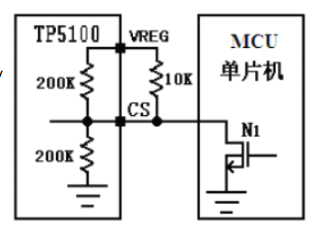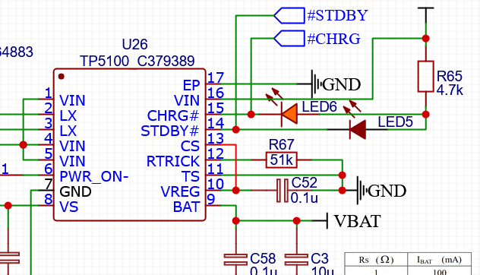 | 19.08.23 DY  Low priority | Prototypes: not implemented. Not tested  SCH: Connect CS pin to Arduino GPIO
E5 | PWR_ON pin is not used.  PWR_ON pin can be used to detect if external power supply is connected. When the chip is connected to the power supply, PWR_ON- Internal switch is pulled low, when the chip is not connected to the power supply, PWR_ON- Internal switch is pulled to a high level VBAT  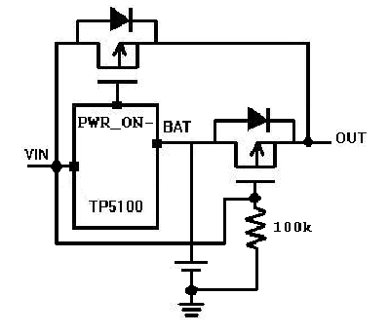  I would consider not implementing this as the power supply can’t provide the same noise free voltage as battery | DY  Low priority | Prototypes: not tested  SCH: implement only as placeholder. Do not populate in the assembly
E6 | Add silkscreen to charg status indication LEDs | DY | SCH: no changes  PCB: silkscreen update
E7 | Change VIN / VBAT short to diodes or remove completely. Creates potential to use VIN+VBAT when they are shorted. → shorting 7V by 9V | DY  Low priority | SCH: add diode in series with 0Ohm resistors. Populate diode, not populate resistors  done
E8 | Test points are too big. To be reduced in the next revision.  Add several big testpoints to the bottom side to enable for futute automated testing. | DY  Low priority | SCH: replace TP parts by smaller diameter ones from the library E.g. tp11, tp12  Add extra big testpoints  PCB: small testpoints on TOP. Big testpoint on bottom. Don’t put TPs under the display
E9 | Battery charger produces audible noise in higher frequencies when no load is connected or battery is charging. No idea how to fix for now (except for changing IC). I think it’s not critical for now. | DY | No action for now
E10 | I2C addresses for LCD screen and ADS1015 do not show up when doing address sweeping. Additionally, communication cannot be established if explicitly given the correct address.  Screenshot from the datasheet  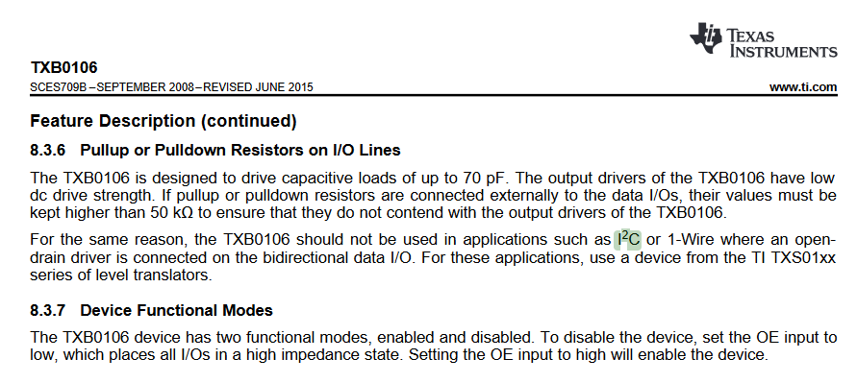  TXB0106 can’t be used for the I2C as it’s requires open drain translator. TXS0108EPWR is suggested. On the other hand, the MUX control circuitry requires the push pull drive. Therefore it can’t be done by single level converter. | 21.8.23 MD Anderson  High priority | Prototype is fixed using descreet transistor solution.  SCH: Implement the level conversion using discreet components:  This circuit for MUX  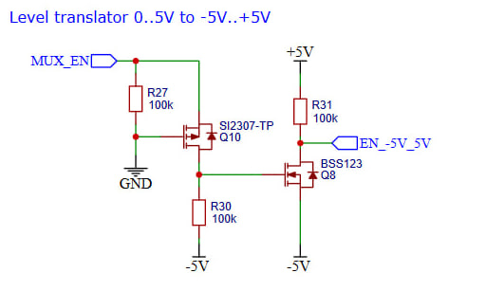  And for I2C use dedicated 2 channel level translator IC
E11 | PD enable pin on AD8137 is given too much voltage. 1.1V is threshold and if 5V is used, too much power is drawn and noise introduced. Unclear if 3.3V logic that we have negatively affects it. | 21/8/23 MD Anderson  High priority | SCH: PD on schematic can be left unconnected 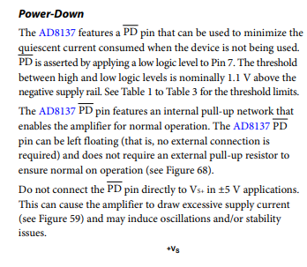
E12 | AD8137 IC giving uncharacteristic output as referenced in section 3.7.  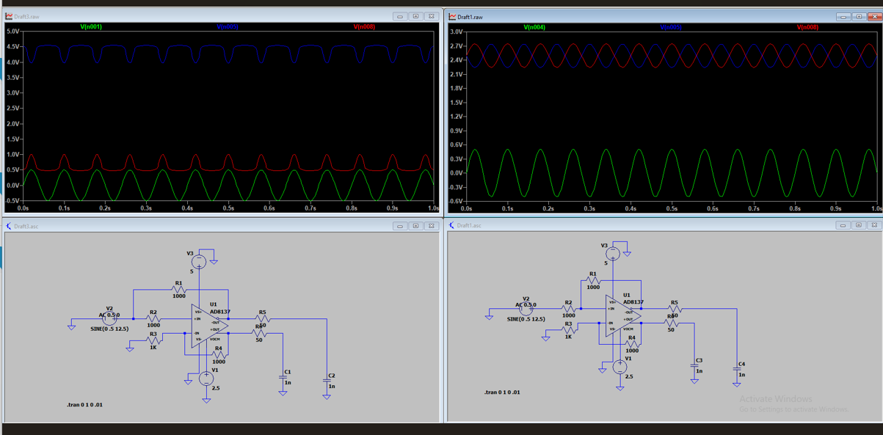  According to simulations, I misplaced resistor (R18). Should be between TP14 and junction to pin 8, not on path to pin 8 | 23/8/23 MD Anderson  High priority | Prototypes: reworked as per § E12 AD8137 feedback resistor  SCH: fix the R18 connection
E12 | Change the LDO to the one with EN pin.  Move the LDO futher away from the battery on the layout to not add additional heat to the batteries | 23/8/23 DY  Low priority | Not tested on prototype  SCH:pick 5V LDO with EN pin. Implement it on SCH. Check the power rating  Done  PCB: move the LDO further away from the battery
E13 | Just idea  Try to simplify this circuit  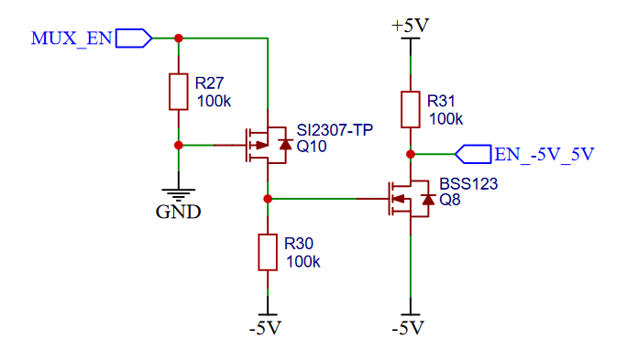  using this architecture  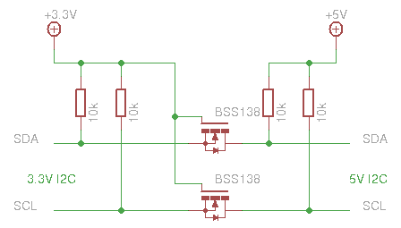  Rejected. See the simulation file:  D:\GitHub\Flexi-TEER\Electronics\3_Calculations&Simulations\Level_shifting_circuit\Level shifter for negative 5V.asc  Proposed circuit can translate ground referenced voltages but fails with negative voltage. In this circuit the lower voltage always wins. So it’s assumed that both sides are pulled up to something higher than the common zero level.  Simplification of the circuit by using the level shifter from 3V3 to -5V by referencing it from -5V is also rejected as the input signal will not be able to achive -5V to signal zero. Will always be high. | 28/08/23 DY | No action required
E14 | Add hardware power switch feature.  To disconnect batteries from the load without having to extract them. | DY  Low priority | SCH: select component for the switch. Implement on the schematic
E15 | When Arduino is connected to PC there is 4.7V on the VIN Arduino pin powering the rest of the circuit.  Add diode  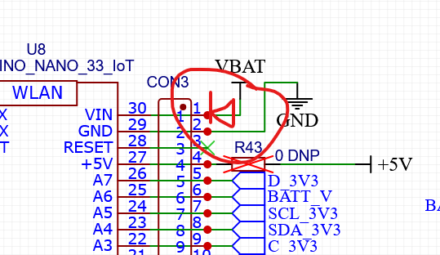 | DY  Low priority | Not tested on prototype  SCH: Add diode to prevent powering the PCB from Arduino board
E16 | Increase the binding posts holes diameter to fit M3 studs | DY  Low priority | SCH: no action required  PCB: Update the PCB holes diameter
E17 | Update the device block diagram on the schematic:  - ADC I2C interface must be connected after the level shifter  - Level shifting architecture must be updated to rev.2 | DY  Low priority | SCH: update block diagram. Put new diagram on the schematic  DONE
E18 | Connecting both STBY and CHRG pins from charger IC to MCU is redundant. Current implementation allows for battery voltage to be applied to the MCU pin | DY  Low priority | SCH: disconnect STBY pin from battery
E19 | Arduino DAC is supplied from DCDC converter and it’s output voltage is too noisy. External DAC must be used and supplied from Batteries and LDO | DY  Mid priority | SCH: add external DAC to the schematic. Use MCP4725
E20 | 5V LDO output features 60mV amplitude noise when the negative charge pump is supplied from it. Separate LDO from Vbat to negative charge pump supply must be used to avoid introducing noise into analog circuits. -5V charge pump output voltage shall be filtered to achieve low noise levels | DY  Mid priority | SCH: Charge pump requires 5.3V separate LDO according to this thread on TI forum
E21 | Add pull up to U3 EN (-5V_SD). -5V supply can’t be off when the +5 supply is available. It creates uncomfortable situation for the opamps supplied from both + and -5 Volts | DY  Mid priority | SCH: pull up the -5V gen. EN, and use the same arduino pin for +5V and 5.3V LDO enable
E22 | Add placeholder for the charge pump artificial load to avoid the FPM mode  Possibly will be resolved with increased input voltage | DY  High priority | SCH: add 220 Ohm load to -5V supply rail check the power rating
E23 | Add 1Meg pull down on the measurement line | DY  Mid priority | SCH: add 1 Meg to avoid measurements noise with open load
E24 | R48 is picked as 100k in BOM instead of 102k | DY  High priority | SCH: change R48 LCSC part number property. Update BOM
E25 | Consider Lm317 as linear battery charger option | DY | No action required (for future consideration)
E26 | Replace the U30 by single channel OpAmp (as 1.65V rail is not used anymore). TS321 can be used | DY | SCH  DONE
E27 | Replace OpAmp symbols with ones that represent the opamp instead of squares (DYwill do after layout update) | DY | SCH
E28 | Consider battery reverse polarity protection | DY | No action required (for future consideration)
E29 | Add CLC filter for the LCD connection to 5V power | DY | SCH
E30 | Replace AD8137YCPZ-REEL7 by AD8137YRZ-REEL7 (use SOIC package). It’s bigger and hand-solder freindly | DY | SCH

Actual boards status

# | Sticker number | Last updated by | Last updated on | Status
1 | HS1 | DY | 01-Oct-2023 | Label applied.  Visually inspected.  L4 inductor soldered.  Arduino installed  Powered ON with batteries. Voltages measured  E12 rework applied  External breakout PCB is soldered instead as E10 fix
2 | HS2 | DY | 01-Oct-2023 | Label applied.  Visually inspected.  L4 inductor soldered  E12 rework applied  E10 rework applied with mistake.  Rework correction to E10.2 (traces to LCD returned)  MOSFETs changed to BSS138

Rework instruction
Equpment required:
- Soldering iron with knife tip
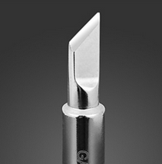
- solder
- flux
- tweezers
- side cutters
- pice of wire

E1 Battery holder

Apply 0.7 mm thermal shrinking tube to the near battery holder pins
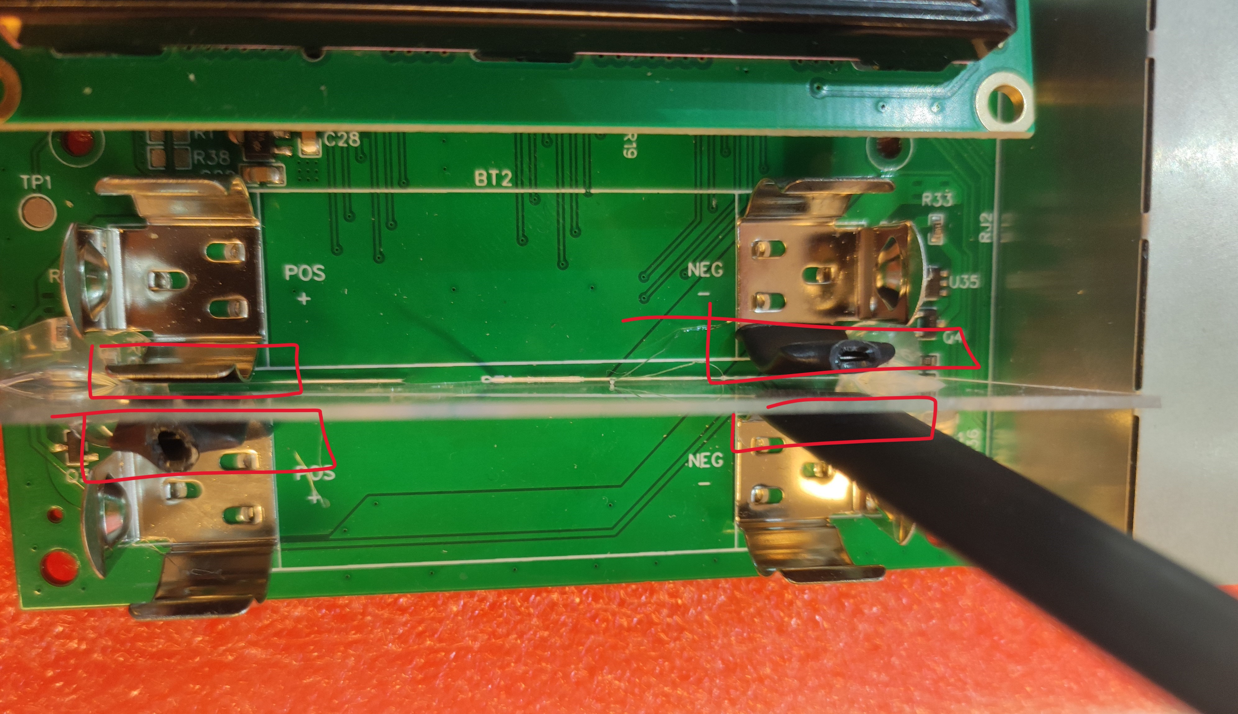
Alternatevley, cut the piece of plexiglass and insert it between the holder jaws to avoid shorting.

E3 AREF pin

Rework strategy:
- Disconnect A7 GPIO from PD pin of the U4
- Disconnect AREF from D_3V3 signal
- Connect A7 GPIO to D_3V3 signal

Demonstration:
1. Cut the PCB trace as demonstrated below:
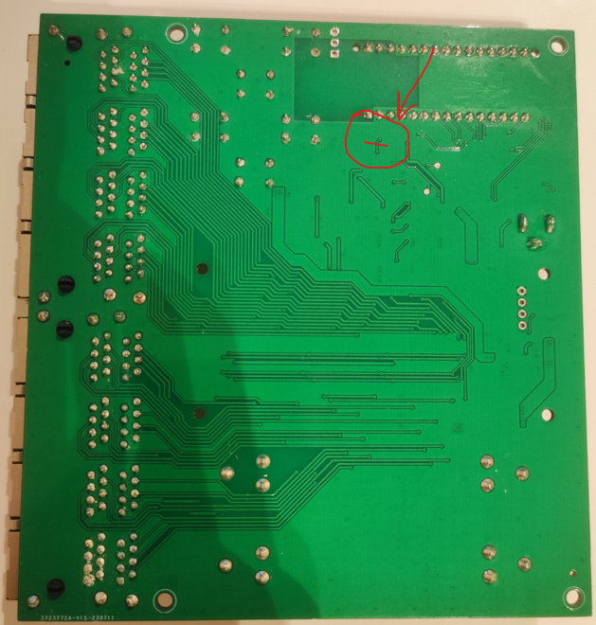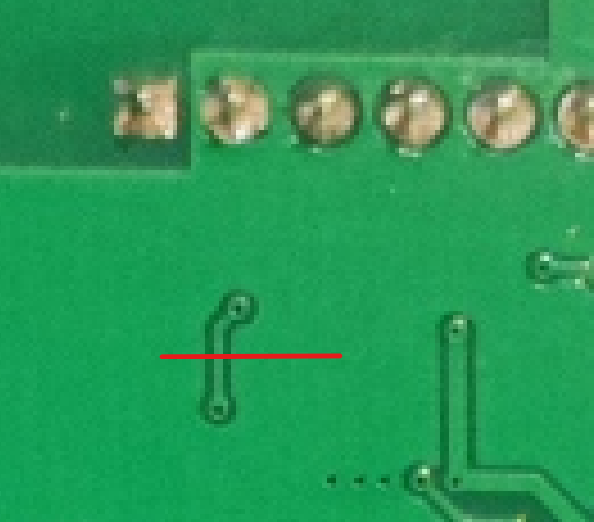
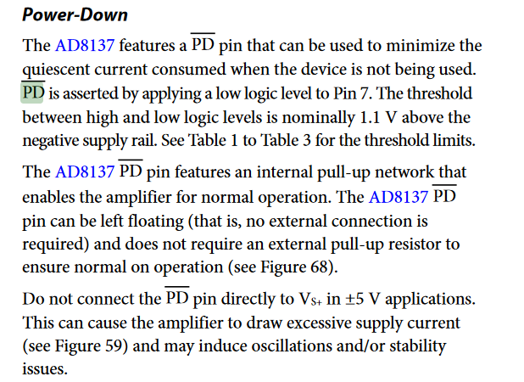

2. Cut the REF pin on the Arduino module flush with the plastic.
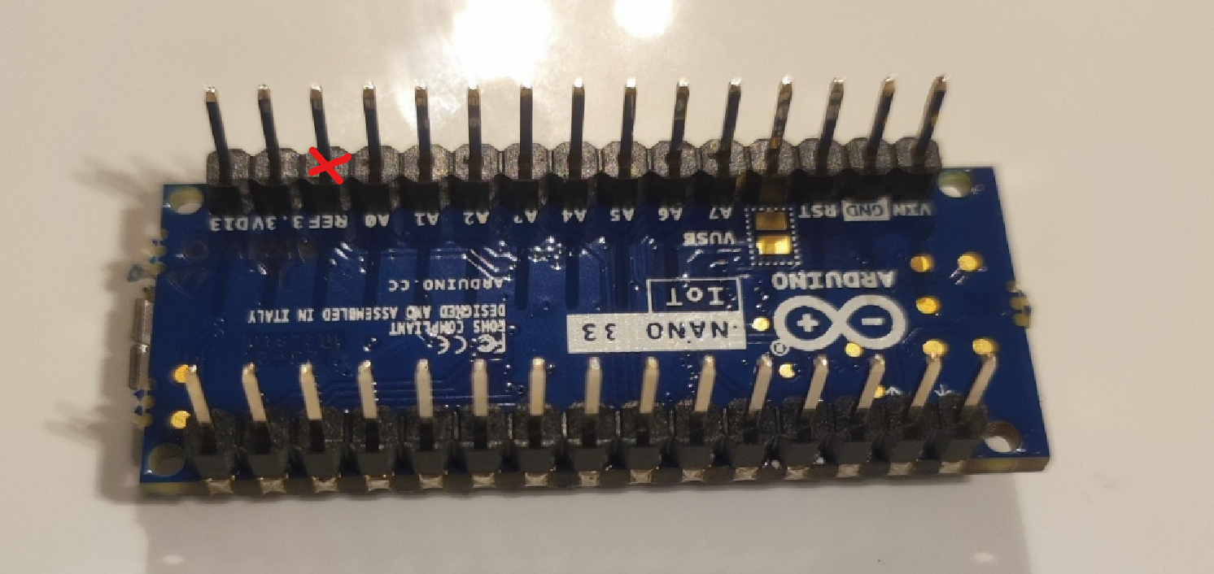
3. Solder the jumper wire between REF and A7 pins on the PCB
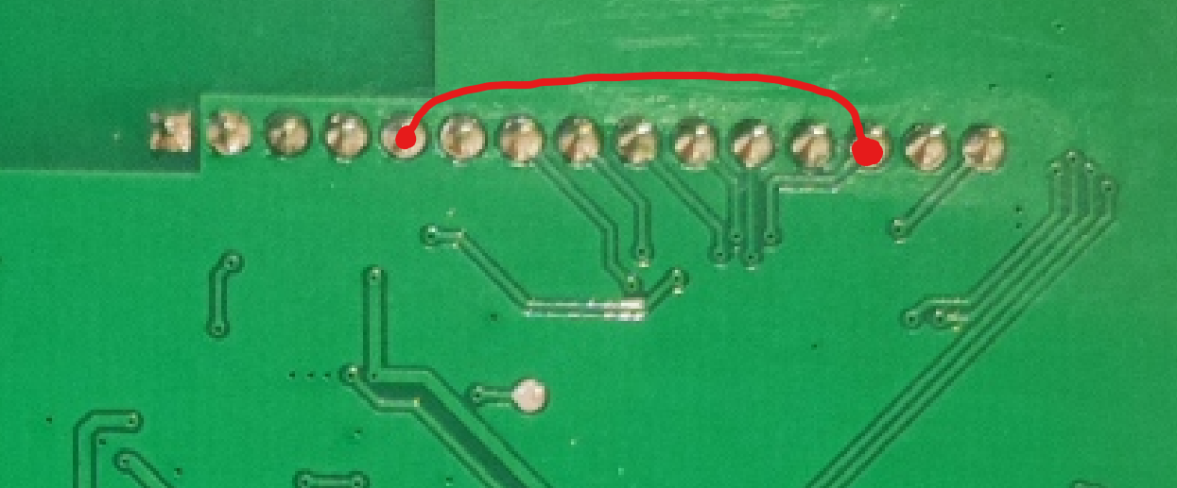

E5 (optional) PWR-ON pin implementation
https://www.mouser.com/datasheet/2/1057/PJA3409-1867412.pdf
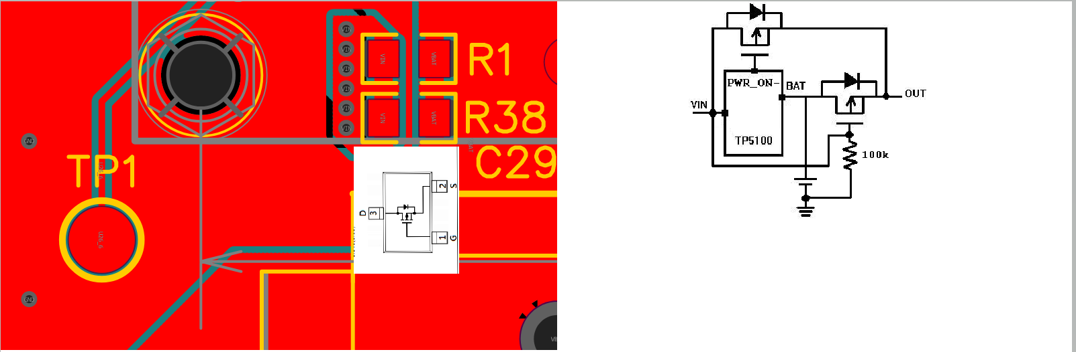

E12 AD8137 feedback resistor
Rotate the R17 resistor like illustrated on the picture below
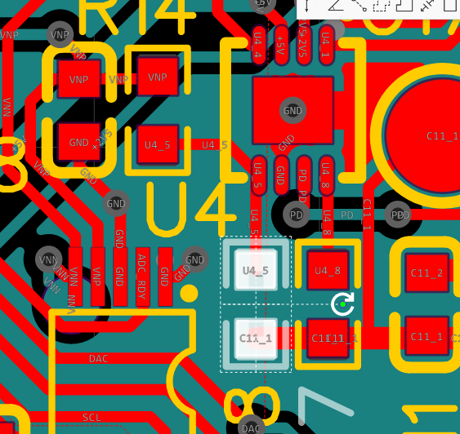=>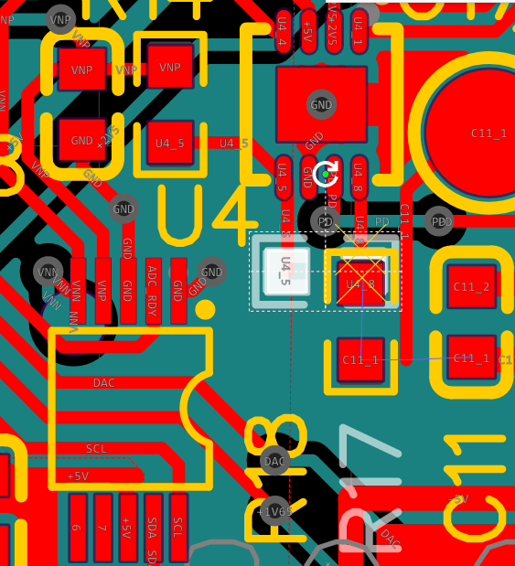

Detailed instruction:
- Apply flux on top of R17 resistor
- Add some solder to the soldering iron tip
- Place the soldering iron in such a way to heat up both sides of the resistor at the same time
- remove the resistor from it’s footprint
- Place the resistor with tweezers as per the picture above
- Solder it one side at the time

This rework instruction is available as a video.

E10.2: level translator and I2C

Original circuit:
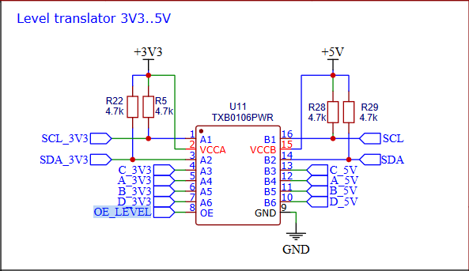
Required circuit for I2C

Rework idea:
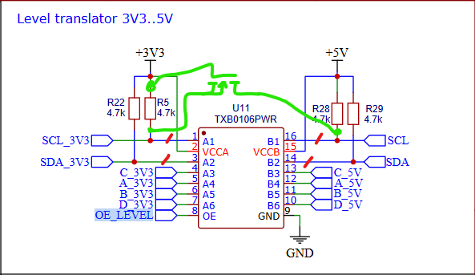
The transistor I will use for the rework: pja94n02 panjit (datasheet)
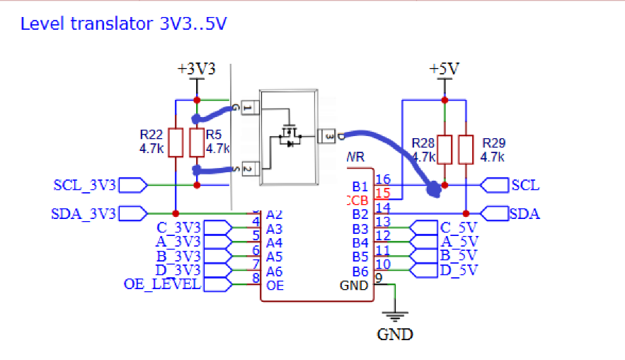

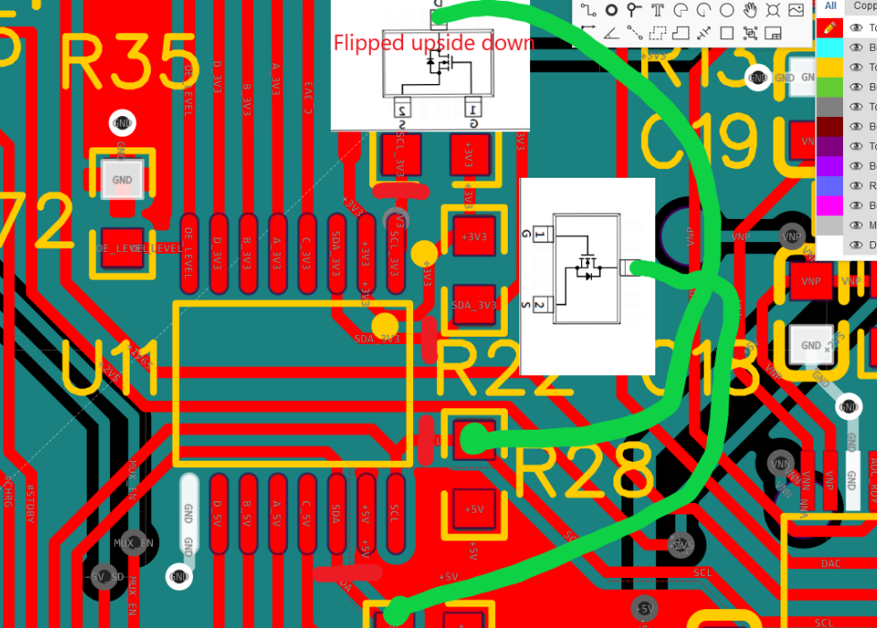

Step 1. Cut 4 traces:

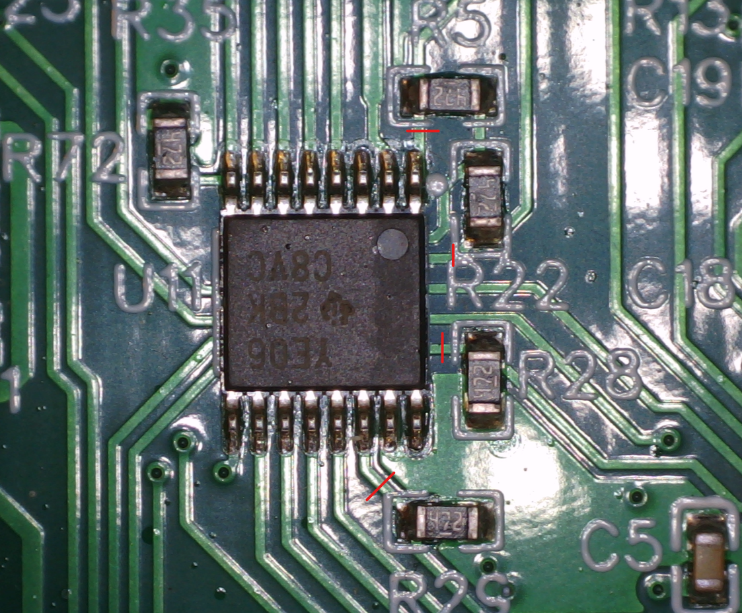

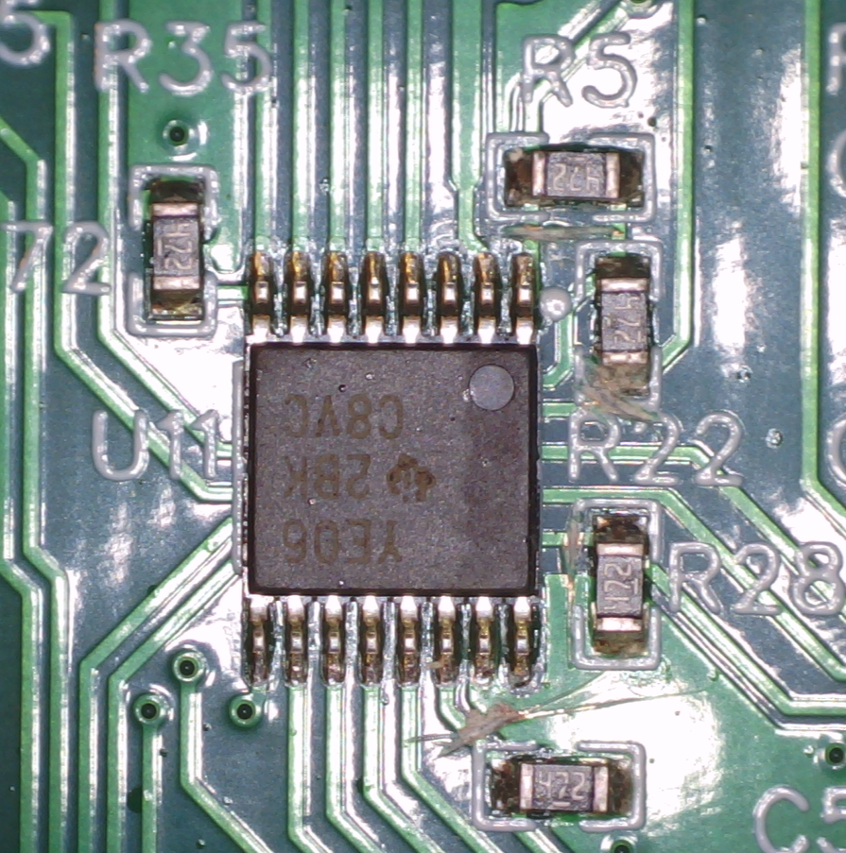

Measure continuity to ensure proper cut.
Place the transistors
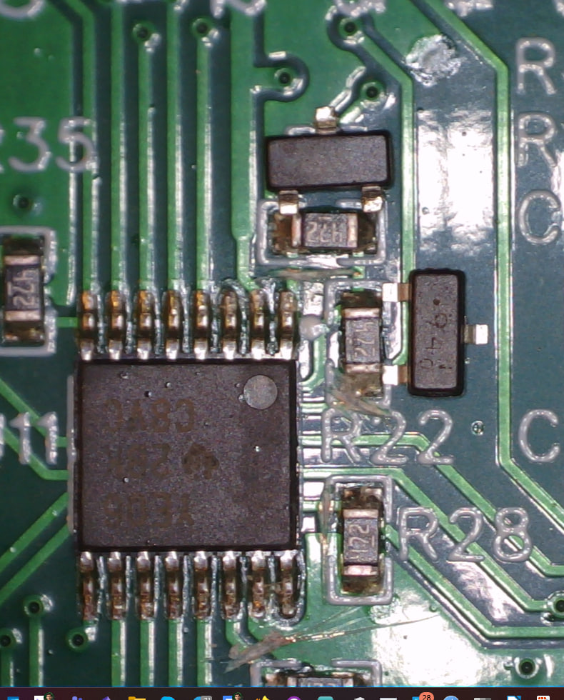
Solder them


